

DISASTER PLANNING FOR PETS WITHIN SURF COAST SHIRE

Profile

"To promote the safety and well
being of animals which are or may
be adversely affected during a
disaster"

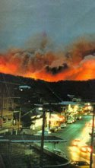

OPERATIONS MANUAL

Domestic Animals Disaster Evacuation Group

This group was formed on 10 August 2005 as a Surf Coast Shire initiative in conjunction with its members.

The members consist primarily of dog and cat boarding proprietors along with Surf Coast Shire representatives (Authorised Officers) with a concern for the welfare of pets belonging to people who have been displaced from their homes during a disaster such as fire or flood.

This operations manual has been produced for members of the Disaster Evacuation Group and interested parties. It should be used as a training manual and be taken to evacuation centres and be utilised as a reference manual.

Thank you for your interest and support of the DADEG (Domestic Animals Disaster Evacuation Group).

Tony Rolfs
Authorised Officer
Surf Coast Shire


What is the Domestic Animals Disaster Evacuation Group? (DADEG)

The above group was formed by Surf Coast Shire along with boarding kennel/cattery owners within the Shire, so that domestic pet owners who evacuate their residences with their pets as a result of a disaster such as fire or flood etc, can take some positive action regarding their pets.

According to the State Emergency Service, most emergencies have shown that pets can be a huge problem when people are evacuated. The Ash Wednesday bushfires in 1983, the 1993 floods in Northern Victoria, particularly Benalla, and more recently Hurricanes Katrina and Rita in the USA, demonstrated that pets at evacuation centres must be considered, and where possible, managed.

What will the Group do?

During an emergency, the Group will collect small domestic animals (dogs, cats, birds, rabbits etc) from consenting owners that have been sent to evacuation/welfare centres approved by emergency services. The animals will then be taken to the SCS pound and to local Council approved boarding establishments and be cared for short term. The owners would then collect their pets when they have reorganised their lives and found suitable accommodation.

Why is the Group needed?

Animals are not allowed inside evacuation centres and during past emergencies animals have been left in cars or unsuitable places often for days. Accordingly, the vast number of animals at evacuation centres has caused confusion for emergency personnel who have been unsure as to what to do with the animals.

In the case of large bushfires, it may be several days before residents are allowed to return to their homes.

According to the State Emergency Service, approximately 80% of people evacuated who have lost homes are able to find accommodation straight away for themselves and their pets. It is the pets of the remaining 20% of owners, who have nowhere to go, that the Group will be able to provide this service for.

What is an Emergency Response Pet Plan (ERPP)?

This plan identifies who is responsible for various tasks during pet emergencies and how the resources of the Shire/State can best be used to combat any emergency.

The principles behind these plans are:

- When any emergency occurs within a community, the affected people will, in the first instance, look for and accept help from local people and authorities with whom they deal every day, they know and have links with.

- When an emergency involves more than one Municipality, (we border with City of Greater Geelong, Colac Otway Shire and Golden Plains Shire), crosses a Municipal border or requires resources from other areas, plans exist for escalation to a Regional basis or a State basis, where large scale assistance and resources can be provided.

Coordination

Local Government, State, Zone and Regional Emergency Response Coordinators have been appointed to coordinate emergencies (coordinating an emergency is basically bringing together all the agencies and resources needed to combat the particular emergency and overview the whole situation).

Responsibilities

Some organisations have been given 'combat or lead agency' roles for specific emergencies or tasks related to emergencies.

Examples of combat or lead agencies include Dept Primary Industries, Red Cross, SES, Police, CFA and Department of Human Services.

Our Group will be listed as a support organisation to the Emergency Response Pet Plan within the Surf Coast Shire and therefore will be called upon by one of the above agencies to assist with animals at an evacuation centre.

See map of the Surf Coast Shire district attached.

How much will it cost?

It is anticipated that most animals would be collected by their owners within one week with minimal costs involved.

SURF COAST SHIRE DISTRICT ERPP

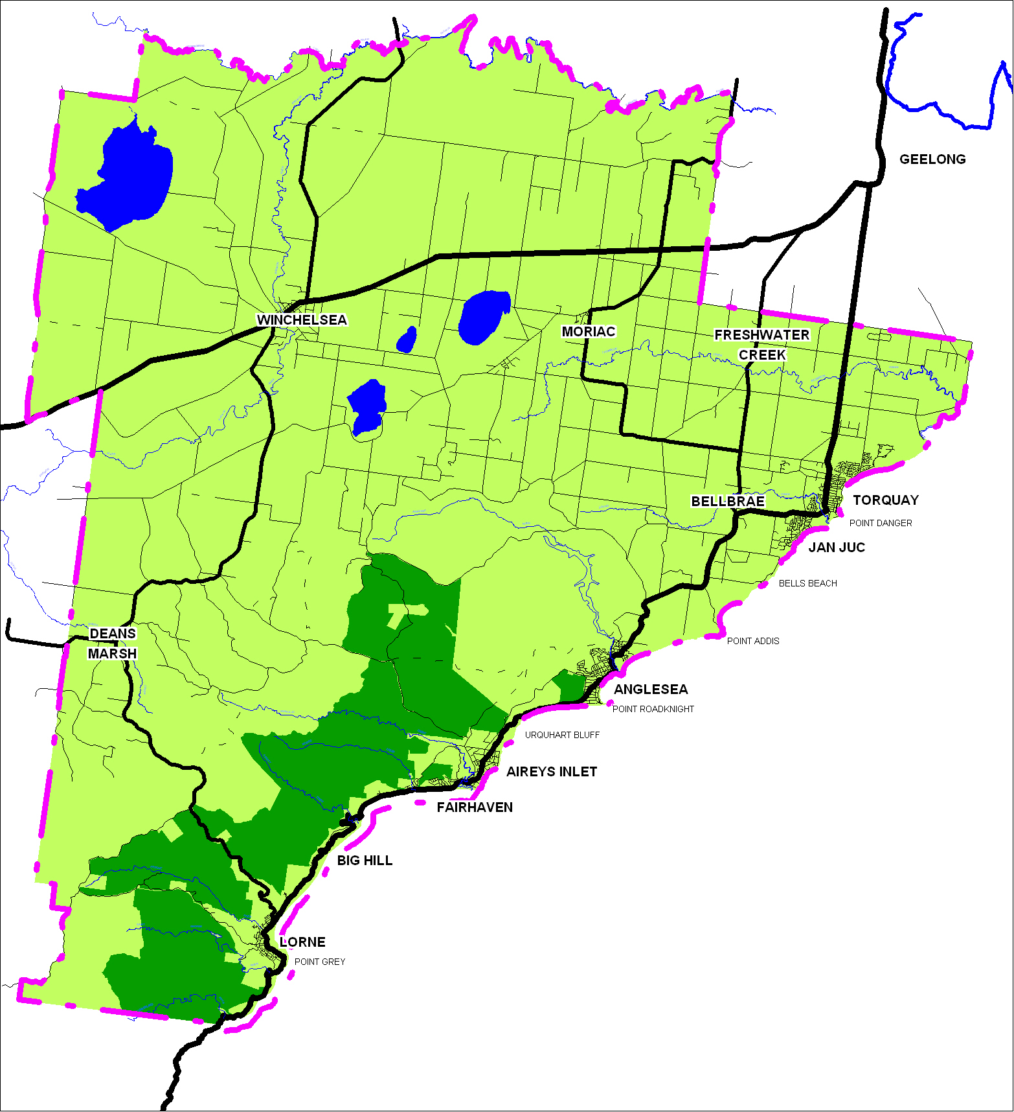
LIST OF GROUP MEMBERS WITHIN SCS

Tony Rolfs 0400 664 601
Trevor Doueal 0418 564 956
Robert Pitcher 0437 240 828
John Bauer 0400 662 034

Authorised Officers
Surf Coast Shire

Approximate availability: 10+ spots

Able to collect, transport and board animals to Blackgate Road Torquay (SCS pound) and assist on a 'hands on' basis.

Members able to collect, transport and board animals:

Mary Ann & Barry O'Reilly
The Dog House Pet Resort
575 Ghazeepore Road
MT DUNEED VIC 3216
Telephone: 5264 5026

Approximate availability: 20 spots (cats only)

Sandra & Peter Dempsey
Woodleigh Boarding Kennels
85 Old Lorne Road
DEANS MARSH VIC 3532
Telephone: 5236 3341 Mobile: 0437 172 244

Approximate availability: 20 spots

Members able to only board animals

Approximate availability: 80 spots

Robyn Stewart
Geelong Animal Welfare Society (GAWS)
325 Portarlington Road
MOOLAP VIC 3219
Telephone: 5248 2091 A/H: 5248 2626
Mobile: 0407 317 436

Vets to board/treat animals:

Anne Fowler
Torquay Animal House
120 Geelong Road
TORQUAY VIC 3228
Telephone: 5261 6486 Mobile: 0418 507 930

Approximate availability: 20 spots

Dr Neil Howard
Torquay & Surf Coast Veterinary Hospital
29 Surf Coast Highway
TORQUAY VIC 3228
Telephone: 5261 6486

Approximate availability: 15 spots

NB: All approximate availability is based on off peak times.

- Group members may also contact their own network of helpers for extra assistance, animal handling and transport etc during an emergency

- Should the number of animals exceed the housing capabilities of the group members, other boarding facilities who are not actively involved with the Group as well as other Veterinary Clinics (outside the area) will be asked for assistance

LIST OF BOARDING ESTABLISHMENTS OUTSIDE SCS

Boarding Establishments able to collect, transport and board animals

Elizabeth Simpson
Tsu Lin Boarding Kennels
295 Banks Road
MANNERIM VIC 3222
Telephone: 5251 2924 (24 hours)

Approximate availability: 22-32 spots

Steve & Wendy Ogilvie
Peninsula Boarding Kennels
475 Bellarine Hwy
MOOLAP VIC 3221
Telephone: 5250 1974 (24 hours)

Approximate availability: 50 spots

Mary McKeegan (requires partner for transport)
The Rockmar Cattery
20 Kancy Street
MOOLAP VIC 3219
Telephone: 5250 2442 (24 hours)

Approximate availability: 15 - 20 spots

Vivienne Benham
Tallywood Boarding Cattery
177 Jetty Road
DRYSDALE VIC 3222
Telephone: 5251 2246 Mobile: 0412 648 526

Approximate availability: 12 spots

Glenda Human
Annalee Boarding Cattery
44 Coppards Road
NEWCOMB VIC 3219
Telephone: 5248 2246 Mobile: 0407 345 295

Approximate availability: 20 spots (cats only)

Boarding Establishments able to only board animals:

Tehree Gordon
Jirrahlinga All Pets Boarding Centre
Taits Road
BARWON HEADS VIC 3227
Telephone: 5254 2484

Approximate availability: 100 (mobile pens also available)

Elizabeth Guthrie
Oasis Boarding Kennels
15 Coonawarra Drive
LARA VIC 3212
Telephone: 5282 1990 Mobile: 0412 830 763

Approximate availability: 60 spots (no cats)

- It is important to familiarise yourselves with the locations of all kennels and catteries to avoid disorientation and confusion when delivering pets after a disaster.

Vets to board/treat animals outside SCS

Dr Wayne Stewart
Leopold Veterinary Clinic
40 Ash Road
LEOPOLD VIC 3224
Telephone: 5250 3350

Approximate availability: 20 spots

Call out procedure

- Telephone call is received from Emergency Services

- Surf Coast Shire Authorised Officers to establish the following:

Where evacuation centre is
Who is the contact person at the centre
What resources are required

- SCS Authorised Officers to call members (see flow chart) with information
received from evacuation centre(s).

- Authorised Officers to ring other boarding facilities as listed:

- With information received from Emergency Services
- To establish what space is available in those facilities
- To find out who can go to the evacuation centre for animal collection and distribution
- Or establish who has space but is unable to leave their boarding facility
- Establish what cages, leashes, transport etc is available and who will take it to the evacuation centre

- Authorised Officers collate information received and then call members with this information (who has what space and who can go etc) and this information is then passed on via the phone network IE fax, email, SMS.

- Personnel to go to evacuation centre(s) and after making contact with person in charge at centre, to collect animals from those owners needing help and distribute to boarding facilities.

- Ensure that you take with you your identification badge identifying you as a member of the Group, along with your equipment kit (contents listed on the Equipment Check List page)

- Personnel to report back to Authorised Officers when finished.
CALL OUT TELEPHONE LIST

Surf Coast Shire/Police/SES/CFA

Surf Coast Shire - Authorised Officers

GAWS N Howard Dog House Pet Resort Torquay Animal House Woodleigh Boarding Kennels
(receive) (receive) (collect/receive) (receive/treat) (receive)

(Boarding Establishments to assist SCS if required)
Tehree Gordon (Jirrahlinga)

Peninsula Kennels Oasis Kennels Annalee Boarding Kennels Tsulin Boarding Kennels Tallywood Boarding Kennels
(collect/receive) (collect/receive) (collect/receive) (collect/receive) (collect/receive)

Procedure at Evacuation Centre

- Ensure you have sufficient petrol in your vehicle. Do not speed.

- Park your vehicle in the carpark or vicinity of the evacuation centre (probably a community hall - but do not block the entrance to the evacuation centre.

- Ensure you have sufficient leads, cages, animal identification tags, forms, biros to handle the animals competently.

- Authorised Officers to explain that the Group members (who are outside the hall) have been called in by SES or Police and briefly explain the Group's role. It is possible that the person in charge of the centre may be able to make a general announcement to the public present that you are there.

- If an announcement has been made, owners may approach individual Group members. Otherwise approach owners who have pets with them and explain that you would like to assist with housing their pet if they need it. You can only assist owners who consent to releasing their pets to the Group.

It is the role of the Group to only take pets from owners who have nowhere to keep their animals for the next few days. Some owners may only be at the evacuation centre for registration purposes and have somewhere suitable to live and take their pets.

- Group members to check vehicles in the vicinity for animals locked in cars or tied to trees etc and attempt to find owners of these animals.

- Check list when a pet is presented for transportation to a boarding facility:

- Confirm the person is the owner
  - Briefly explain what the Group is doing
  - If the owner wants to release their pet to our Group, ensure the information sheet is completely filled out and the consent and release form is read and signed.
  - Place the hospital/travel tag on the animal (around neck or other place where it cannot be accidentally removed). The information on the tag will be its name, home suburb and the boarding facility to which it is going.
  - Place animal in a cage and into a vehicle or into an animal trailer for transportation. Or the owner may wish to take their pet to their appointed facility in their own car and follow you when you leave.
  - Whenever possible encourage owners to keep their pets' personal items (eg food bowls) and only take essential items necessary for the care of the pet.
  - Authorised Officers will know how many animals are being taken to which facilities, and should ensure that animals are placed in groups according to their destinations.
  - If an animal has been brought in by someone other than its owner, process the animal in the same way, but instead of filling in the consent form, use the exercise book provided for this circumstance and nominate GAWS as the animal's boarding facility.
  - There is no need to rush, remain clam and speak quietly to the owners.
  - Present and help them to fill in their consent forms if they need assistance. (Remember they could still be in shock).
  - Where possible enlist the owner's help in tagging their animal and placing it in a container or vehicle.

  - Do not insist on removing animals from owners who do not wish to relinquish them.
  - When you have collected those animals present, Authorised Officers should notify the person in charge of the evacuation centre that you are leaving.
  - Authorised Officers to determine the likelihood of further assistance being needed from the Group.
  - Transport the animals to their various nominated boarding facilities.

Equipment Check List

The equipment to be taken to an evacuation centre will include:

- Digital camera to photograph all animals.

- Spare dog leads, cat bags and cages which are owned by the individual boarding establishments. These should be clearly marked with the boarding establishment's name, either written on the item or tagged with a travel tag.

- Dog leads etc which are owned by the Group and have been distributed to the members for use in an emergency.

- A quantity of hospital type/travel tags issued to each Group member for identification tagging of animals at the evacuation centre.

- A small first aid kit to treat injuries to Group members including bites and scratches.

- A quantity of Consent/Instruction Forms which have been distributed to each Group member.

- Spare pens.

- Spare pairs of scissors to cut hospital type animal tags.

- Photograph and record animals which have been brought into an evacuation centre without owners.

- Badges/laminated identification badges.

Domestic Animals Disaster Evacuation Group (DADEG)

What is the DADEG?

We are a group made up of SCS representatives and cat/dog boarding facility owners who want to offer emergency short term accommodation for your loved pet at a time when a disaster such as today has happened.

What does the Group do?

We will take your pet to a Council approved boarding facility for a short time until you are able to reorganise your life and be able to collect your pet. Your pet will be loved and well cared for in your absence at the boarding facility.

CONSENT FORM

If you would like to use our service please complete the information below:

Your Details:

Name: ……………..………………………………….…..………………..………………………
Address: ……………………… …………………………..……………………………..…………..
……………………………………………………………………..………………………..
Phone No: ……………Mobile: …………...……..………………Email:………..…………
Temporary Address: …………………..……...………………………..……………………………….
…………………………..………….……………………...……………...………………..
Name of Employer: ………………..………...…………………………..……………………………..
Employer Phone No: ……………..…………..……………………..……………….…………………

Pet Details
Type of Pet: ……………Breed:…………………………………… Microchip: Yes □ No □
Colour(s): ……………………………………......... Sex: Male □ Female □
Council Tag No:……………………Pet's Name: ……..……………………… Age: ………………..
What medication is your pet taking? …………………………………………………..………………
Do you have this medication with you: Yes □ No □
What vaccinations has your pet received in the last 12 months? ….……………………………….
Are there any special instructions we must know to help us to care for your pet?
………………………………………………………………………………..……………………………
The Nominated Boarding Facility Details:
Your pet will be taken to:
Facility Name:……………………………………..……………………………………………………..
Facility Address: …………………………..…………………………………………………………….
Contact Person: ………………………………………Phone No: …………..………………….

Please contact the Boarding Facility within 48 hours to arrange collection or to give a report on when you can collect your pet.

Please read and sign the Agreement & Release Form (below)
I, the above named give DADEG permission to transport my animal(s) to the nominated boarding facility (named above) and indemnify the Group/Surf Coast Shire of any costs and/injuries that may occur in this process and whilst being cared for by the nominated Boarding Facility.

Name: …………………………………………………………………………………..
Signature: ………………………………………………………….………..………………………..
Date: …………………………………………………………………………………..

- Any additional input/feedback would be most welcome and appreciated to Tony Rolfs at:

trolfs@surfcoast.vic.gov.au or by mobile 0400 664 601

