Dear _________________________
RE: Kerbside four-bin system
As you may be aware, Surf Coast Shire changed to a four-bin kerbside service on 1 February 2021.
The change included:
- introduction of a glass-only bin for empty glass bottles and jars without their lids
- acceptance of all household food waste in the existing FOGO (Food Organics and Garden Organics) bin
- change in collection frequency for some bins.
I’m contacting you to ensure that you and your staff are aware of the collection frequency of each bin type so they are not placed on the kerbside on the incorrect collection week.
The following kerbside bins are now used at this address __________________________________:
- FOGO bin (lime green lid) for all food waste and garden waste.
- Recycling bin (yellow lid) for rigid plastics, metal cans and tins, paper and cardboard
- Glass-only bin (purple lid) for empty glass bottles and jars without their lids
- Landfill bin (red lid) for items that can’t go in the other three bins.
The bins will still be emptied on a ____________________, but there have been changes to the collection frequency of the FOGO and landfill bins. Here is how often each bin is collected:
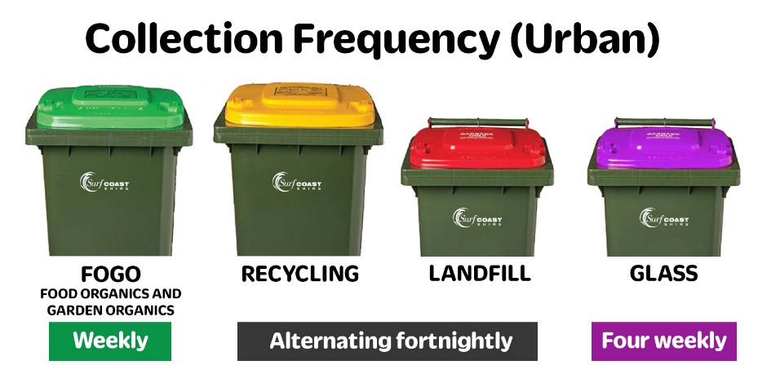
To help your cleaning team to present the correct bins for emptying, I encourage you to download SCRRApp, the Surf Coast Rubbish & Recycling App. You can use SCRRApp to check which bins are due to be emptied that week and can enter multiple addresses if you’re looking after other properties. For more information visit www.surfcoast.vic.gov.au/SCRRApp.
Bin collection calendars are also available on Council’s website www.surfcoast.vic.gov.au/calendars
Please let me know if you have any further questions.

Sincerely,

