

All Aboard disAbility Support Services International Day of People with

Disability Art Exhibition 2020

ACCESS AND INCLUSION PLAN 2014-2024

PROGRESS REPORT: JULY 2018 – DECEMBER 2020 REPORT DATE: JANUARY 2021



TABLE OF CONTENTS

About this report Policy context Next steps

Review of Actions

July 2018 – December 2020

Access and Inclusion Plan Outcomes 2018 – 2020

3

4

5

6

11

1 | Access and Inclusion Plan 2014-2024

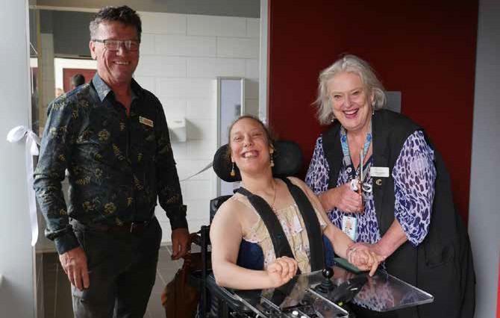

ABOUT THIS REPORT

This report summarises Council’s progress on the Access and Inclusion Action Plan 2017-2021 for the period July 2018

– December 2020. The Action Plan 2017-2021 supports the implementation of our 10 year Access and Inclusion Strategic Plan 2014-2024.

The Action Plan has been extended (initially for 2017 – 2020), and this progress report delayed due to a gap in the Access and Inclusion Officer role and impacts of the COVID-19 pandemic.

The Action Plan was reviewed by Council’s Access and Inclusion Officer.

For full details on outcomes for all actions please see the Outcomes Report, available on our website.

For more information about Access and Inclusion at Surf Coast Shire Council, please see our website, or contact the Access and

Inclusion Officer by lodging an online request or calling 5261 0600.

Changing Places opening Winchlesea February 2020

SURF COAST SHIRE COUNCIL | 2

POLICY CONTEXT

INTERNATIONAL CONTEXT

The [United Nations Convention on the Rights](https://www.un.org/development/desa/disabilities/convention-on-the-rights-of-persons-with-disabilities.html) [of Persons with Disabilities](https://www.un.org/development/desa/disabilities/convention-on-the-rights-of-persons-with-disabilities.html) (CRPD) 2006 aims to promote full enjoyment of all human rights by people with disability, and to promote respect for their inherent dignity. Australia signed the convention in 2007 and ratified it in 2008.

LOCAL CONTEXT

Surf Coast Shire Council is committed to access and inclusion for all to build healthy, well-connected communities where everyone can participate. The [Accessible and Inclusive](https://www.surfcoast.vic.gov.au/About-us/Council/Policies-plans-strategies-and-reports/Plans-and-strategies)

[Strategic Plan 2014 - 2024](https://www.surfcoast.vic.gov.au/About-us/Council/Policies-plans-strategies-and-reports/Plans-and-strategies) outlines how Council will work towards this goal over ten years.

The 10 year Strategic Plan outlines goals for how Council will achieve the plan’s five key outcomes over the next 10 years. Council has short-term Access and Inclusion Action

Plans which outline how we will progress each of these goals, and how we will measure our performance. The current Action Plan 2017- 2021 has been extended due to the impacts of COVID-19.

In May 2020, Council also developed a short- term COVID-19 Disability Action Plan 2020, to guide our work to support people with disability and their carers during the pandemic. This plan had two overarching goals:

Ensure Council’s Covid19 relief and recovery actions are inclusive, accessible and non-discriminatory, and pay special attention to people with disability, who are

disproportionately affected by the pandemic.

‘Build back better’: use our relief and recovery efforts to create a community that is more inclusive and accessible than it was pre- pandemic, where everyone with a disability can participate as active citizens.

FEDERAL CONTEXT

The [National Disability Strategy 2010 - 20](https://www.dss.gov.au/our-responsibilities/disability-and-carers/publications-articles/policy-research/national-disability-strategy-2010-2020) is the framework for all Australian governments to improve the lives of people with disability, their families and carers. It provides a unified, national approach to enable people with disability to participate as equal citizens in Australian society.

The new [National Disability Strategy](https://www.dss.gov.au/disability-and-carers/a-new-national-disability-strategy) was due to be completed in 2020, but will now be finalised in 2021 due to the impacts of COVID-19 on ensuring safe consultation with the community.

STATE CONTEXT

[Absolutely Everyone 2017 - 2020](https://www.statedisabilityplan.vic.gov.au/absolutely-everyone-2017-2020) is the Victorian Government’s plan to achieve greater inclusion and participation for people with disability. The plan’s key areas include

adopting a universal design approach, changing attitudes, increasing access to affordable housing, public transport, schools and jobs.

The new [State Disability Plan 2021 - 2024](https://www.statedisabilityplan.vic.gov.au/) was due to be completed in 2020, but will now be finalised in 2021 due to the impacts of COVID-19 on ensuring safe consultation with the community.

3 | Access and Inclusion Plan 2014-2024

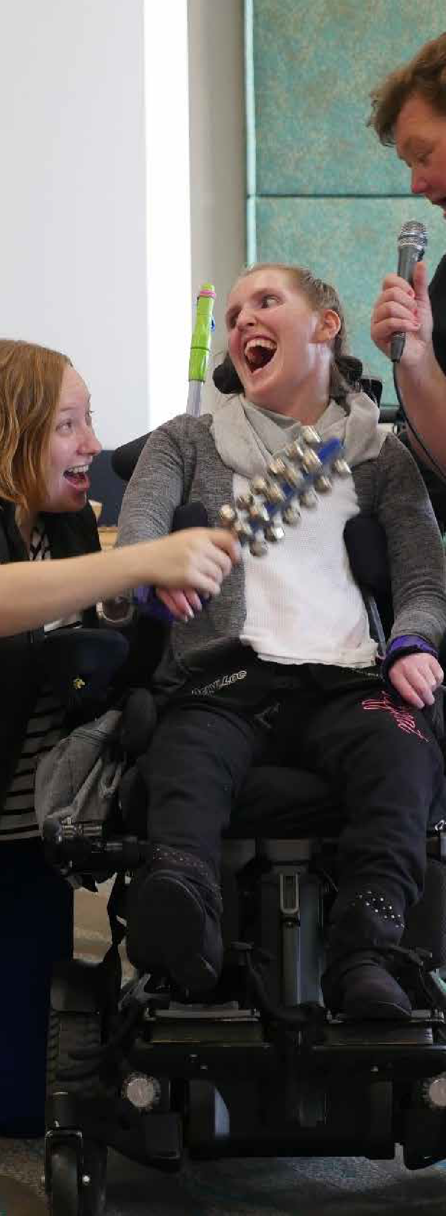

NEXT STEPS

Council will now work towards creating a new action plan for 2021 – 2024, which will take us to the end of the Strategic Plan.

This new plan will incorporate incomplete actions from the current action plan, actions from the COVID-19 Disability Action Plan, and feedback from Council and the community. *genU participant enjoying the Connections TV International Day of People with Disability online event December 2020*

*The Rockheads performing at Council’s International Day of People with Disability*

*event December 2019*

SURF COAST SHIRE COUNCIL | 4





REVIEW OF ACTIONS

JULY 2018 – DECEMBER 2020

For full details on outcomes for all actions please see the Outcomes Report, available on our website.

GOAL (Strategic Plan 2014 – 2024)

1.

Built and natural environments are well designed and accessible for people of all abilities, and planned to adapt to our community’s future accessibility needs

5 | Access and Inclusion Plan 2014-2024

Met or exceeded Work in progress

Not met

ACTION

STATUS

1.1 Ensure all new Council buildings are compliant with the Building Codes Australian Standard

All new council buildings meet the current Australian standards for accessibility. All new council buildings have an accessible continuous path of travel from the car park to the entrance and throughout the building.

1.2 Continue to improve the accessibility of existing council buildings and infrastructure where feasible

Prioritise and include in renewal programs the work to be completed out of the 2014 council building audit report.

1.3 Improve the safety and accessibility of the outdoor environment including walking and cycling paths, playgrounds and sporting facilities

Incorporate Universal Access design and safety into all future master plans for pathways, open space environments, sporting facilities and playgrounds

Continue to promote council resources for hire in the community to improve accessibility in the

natural environment (i.e., beach chairs and trail rider, portable ramp, portable listening system, township access maps)

Continue to implement council pathway strategy and prioritise pedestrian access for all to public facilities such as health services, shopping precinct, recreation facilities and transport

1.4 Increase the ability of staff to understand and apply

current access standards and universal design principles

to Council’s infrastructure planning

Deliver training to relevant staff – Understanding Access Legislation and Universal Design in Buildings

1.5 Increase the capacity of planning applicants to incorporate universal design and improved accessibility in their design

All private developers are to receive information about universal access and disability discrimination via council’s fact sheet “Design for Access”

Showcase two or more businesses in the SCS to promote Universal Design in their planning and development





GOAL (STRATEGIC PLAN 2014 – 2024)

2.

Accessible, flexible, people-centric services and information, responsive to the needs of people with a disability, their families and carers

SURF COAST SHIRE COUNCIL | 6

Met or exceeded Work in progress Not met

ACTION

STATUS

2.1 Improve the ability of staff to respond to current and emerging needs of people with a disability, their families and carers as well as people

with other access and inclusion needs

Access and Inclusion Officer is to meet with the Coordinator of Positive Ageing once per month to discuss and plan for addressing the current and emerging needs of people with a disability as consumers of Council services.

Maintain information and referral pathways that support access to services that provide specialist disability and early intervention programs

Liaise with All Abilities Advisory Committee (AAAC) at the planning and design phase for infrastructure projects that require access considerations.

Develop an online resource “inclusive communication guidelines” for all new and existing staff to access and read

2.2 Apply best practice communication and information approaches to enable easy access to information by people with a disability

Redevelop Surf Coast website and make sure it meets the web content accessibility guidelines – WCAG 2.0

Develop accessible word web based documents for Council Plan, Council Strategies and Annual Report

Promote and encourage All Abilities Advisory Committee (AAAC) to participate in Council’s Digital Engagement opportunities

COVID-19 DISABILTY ACTION PLAN 2020 Pro-

vide COVID-19 information in accessible formats and communicate COVID-19 content specifically relevant to people with disability and carers via all Council commu- nication channels.

2.3 Plan and deliver council events and activities that are inclusive and celebrate community diversity

Partner with regional stakeholders to plan and deliver community event(s) to celebrate International Day of People with a Disability (Usually December annually)

All Council events are accessible for people with a disability and incorporate an access assessment at planning stage

Circulate Arts Matters e-news to Geelong based community services and to Surf Coast Shire community service networks

2.4 Support service providers to develop and deliver services to meet local accessibility needs

Promote the Home Library Service to residents with temporary and permanent disability in the SCS

Engage with employment providers in Geelong (e.g. Ticket to Work, Campbell Page) to identify strategies to create employment and work experience opportunities for job seekers with a disability

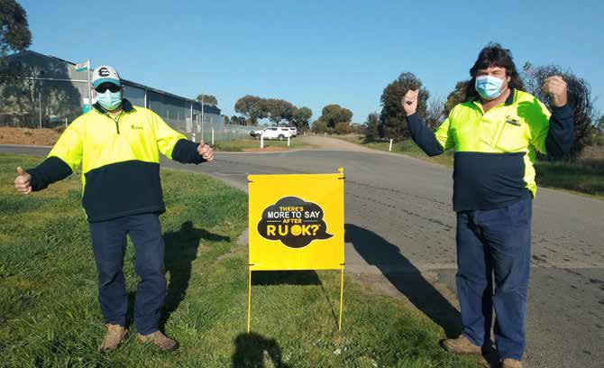



GOAL (STRATEGIC PLAN 2014 – 2024)

3.

People of all abilities actively participate, socialise and have fun in the community and contribute to local decision making

*Depot staff share RUOK day message during COVID-19 pandemic 2020*

7 | Access and Inclusion Plan 2014-2024

Met or exceeded Work in progress Not met

ACTION

STATUS

3.1 Involve people of all abilities in Council’s decision-making

All public community engagement and digital community engagement methods will enable access by people with a disability

3.2 Support community organisations to attract and cater for people with a disability as participants and volunteers

Support and promote arts events that showcase works by people with all abilities

Work with community houses to identify resources to promote inclusion and participation by people with a disability

3.3 Support community arts, festivals and events to be inclusive of all abilities and reflective of community diversity

Update Accessible Events Guidelines and distribute to all Surf Coast Shire event organisers





GOAL (STRATEGIC PLAN 2014 – 2024)

4.

Council actively promotes the importance of inclusion for all, addressing discriminatory attitudes and supporting inclusive practices

SURF COAST SHIRE COUNCIL | 8

Met or exceeded Work in progress Not met

ACTION (ACTION PLAN 2017 – 2021)

STATUS

4.1 Build and recognise community and business knowledge, skills and initiative around local access and inclusion needs

Promote good access as being good for business and tourism in the Surf Coast Shire. This will be achieved by developing a communication plan with key messages and resources to circulate to businesses.

Promote access and inclusion as a favourable criteria when advertising Council’s Community and Event Grant program

Promote iPhone app “Out and About” to Surf Coast businesses via the Economic Development Newsletter

4.2 Work in partnership with government, business and the community to improve access and Inclusion for people with a disability

Provide website links to accessible tourism organisations and resources throughout Victoria (including Travellers Aid and Out and About iPhone app)

Work in partnership with Great Ocean Road Coast Committee (GORCC) to explore opportunities to trial beach matting in two locations along Surf Coast beach spaces

Participate in regional and state-wide networks that advocate on issues important to people with a disability (e.g. improved transport options, new service development in Surf Coast Shire, National State and Local priorities)

Seek relevant funding opportunities and prepare submissions to receive State and Commonwealth Government grants to enable improved access for all.

Explore opportunities for Changing Places funding through State Government grants.

Explore the opportunity for the National Disability Recruitment Coordinator (NDRC) to run an information session with tourism and trader networks

4.3 Advocate to create systemic change and choice for people with a disability

Advocate for improved transport along the coast and between the towns

4.4 Convene and support a community committee to advise council on the provision of accessible and inclusive services, programs and infrastructure

Continue to regularly hold meetings with the All Abilities Advisory Committee (AAAC) and recruit new members as required in line with Terms of Reference. Share relevant information regularly with AAAC.





GOAL (STRATEGIC PLAN 2014 – 2024)

5.

A workforce that embraces diversity and is responsive to the needs and aspirations of people with a disability

STATUS OF ACTIONS OF PREVIOUS PROGRESS REPORTS

9 | Access and Inclusion Plan 2014-2024

Met or exceeded Work in progress

Not met

Progress report date Met or exceeded Work in progress Not met Total

December 2020

24

11

4

39

July 2018

36

2

0

38

July 2017

44

4

0

48

July 2016

20

24

3

47

March 2016

10

34

1

45

December 2015

9

36

1

46

ACTION

STATUS

5.1 Provide staff with the knowledge, support and systems to enable Council to provide equitable and accessible services, programs and activities

Maintain and share information across the organisation to reinforce the importance of inclusive and accessible Council operations

Review all Council building fact sheets and update with information about accessible features for each facility

5.2 Continue to build workforce diversity regarding employment of people with a disability

Implement actions in Surf Coast Shire's diversity commitment under Commitment Focus. Create employment opportunities for people with disability.

5.3 Evaluate Council’s Access and Inclusion Plan annually

Provide annual reports to the All Abilities Advisory Committee (AAAC), all Council staff and to Councillors on progress towards actions. Review and update actions bi- annually.

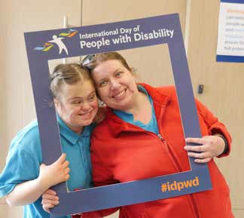

ACCESS AND INCLUSION PLAN OUTCOMES 2018 – 2020

ACCESS FOR ALL IN BUILDINGS, FACILITIES AND NATURAL ENVIRONMENT

Strategic Objective 1:

Built and natural environments are well designed and accessible for people of all abilities, and planned to adapt to our community’s future accessibility needs

INCLUSIVE, FLEXIBLE SERVICES AND INFORMATION

Strategic Objective 2:

Accessible, flexible, people-centric services and information, responsive to the needs of people with a disability, their families and carers

•

International Day of People with Disability events have been held each year to celebrate the contribution and abilities of people with disability.

The Manager Project Management Office attends each All Abilities Advisory Committee meeting to provide an opportunity for members to give a lived experience review on new project plans, since 2019.

During the pandemic in 2020, Council provided timely COVID-19 information in a variety of accessible formats and shared information specifically for people with disability via a range of channels.

•

Disability Discrimination Act (DDA) Compliance Project: Audit of 20 high priority buildings completed December 2020.

Barwon River Pathways Project Winchelsea involved on site consultation with person with lived experience. All high profile locations have provided an accessible pathway or ensured vehicular access is available.

Access improvements to the pathway along Cape Otway Road in Moriac, and Surf Precinct Project accessible path along Beach Road and Baines Crescent Torquay linking pathways.

Professional development on Universal Design provided to 30 staff in July 2018.

•

•

•

•

•

*International Day of People with*

*Disability event 2019*

SURF COAST SHIRE COUNCIL | 10



ACTIVE PARTICIPATION AND LOCAL DECISION MAKING OPPORTUNITIES

Strategic Objective 3:

People of all abilities actively participate, socialise and have fun in the community and contribute to local decision making

•

COVID-19 Disability Action Plan created in May 2020 based on feedback from disability support services, community organisations, schools, and community members

Art exhibitions by All Aboard disAbility Support Services held at Surf Coast Art Space in Anglesea in 2018, and online on Surf Coast Arts Trail Facebook page in 2020.

Upgraded access pathway and accessible car park at Lorne Community House in 2019.

•

•

*All Aboard disAbility Support Services Art Exhibition 2020*

11 | Access and Inclusion Plan 2014-2024

COMMUNITY AWARENESS. SUPPORTING INCLUSIVE PRACTICES

Strategic Objective 4:

Build and recognise community and business knowledge, skills and initiative around local access and inclusion needs

EMPLOYMENT OPPORTUNITIES FOR PEOPLE WITH A DISABILITY

Strategic Objective 5:

A workforce that embraces diversity and is responsive to the needs and aspirations of people with a disability

•

Two new Changing Places facilities opened in 2020 in Anglesea and Winchelsea.

Great Ocean Road Coast and Parks Authority installed 40 metres of beach access matting seasonally at Fisherman's Beach Torquay and Lorne Beach in 2019.

Council successfully advocated to PTV Transport for Victoria on behalf of Anglesea Public Transport Action Group. Resulted

in an additional daily service, re-routed to Waurn Ponds Shopping Centre.

Recruited five new members to the AAAC in 2020, all who have lived experience of disability.

Council explored the formation of a new Surf Coast Disability Network for local disability support services, health and community services and schools in September 2020. First meeting planned February 2021.

Council successfully advocated to Barwon Health Carer Gateway for a new carer support group to be started on the

Surf Coast in response to the COVID-19 pandemic. Coordinator and participants recruited December 2020. First meeting planned February 2021.

•

Council worked directly with APM Employment Services to obtain funding and create an employment opportunity for a person with disability in Council’s Early Years Service in 2020.

During COVID-19 pandemic the People and Culture department provided a range of support to staff with disability to address reasonable adjustment requirements and support their mental health and wellbeing.

•

•

•

•

•

•

SURF COAST SHIRE COUNCIL | 12