Childhood Immunisation Timetable – 2018

Location | Time | Jan | Feb | Mar | Apr | May | Jun | Jul | Aug | Sep | Oct | Nov | Dec
Kurrambee Myaring Community Centre  12 Merrijig Drive Torquay  (1st Wednesday of each month from March) | 9:00am  10:00am |  |  | 7th | 4th | 2nd | 6th | 4th | 1st | 5th | 3rd | 7th | 5th
Torquay Children’s Hub  27 Grossmans Road Torquay  (3rd Wednesday of each month) | 9:00am  10:00am | 17th | 21st | 21st | 18th | 16th | 20th | 18th | 15th | 19th | 17th | 21st | 19th
Moriac Maternal & Child Health Centre  7 Clerke Court, Moriac  (1st Wednesday of each month from Feb) | 10:45am  11:15am |  | 7th | 7th | 4th | 2nd | 6th | 4th | 1st | 5th | 3rd | 7th | 5th
Winchelsea Maternal & Child Health Centre  8 Gosney Street Winchelsea  (1st Wednesday of each month from Feb) | 11:45am  12:15pm |  | 7th | 7th | 4th | 2nd | 6th | 4th | 1st | 5th | 3rd | 7th | 5th
Lorne Maternal & Child Health Centre  Fig Tree House, 16 Mountjoy Pde Lorne  (1st Wednesday of each month from Feb) | 2:00pm  2:30pm |  | 7th | 7th | 4th | 2nd | 6th | 4th | 1st | 5th | 3rd | 7th | 5th
Anglesea Kindergarten  1 McMillan Street Anglesea  (1st Wednesday of each month from Feb) | 3:15pm  3:45pm |  | 7th | 7th | 4th | 2nd | 6th | 4th | 1st | 5th | 3rd | 7th | 5th
No appointments necessary. Please bring your Medicare card and your child’s Health Record book to the session

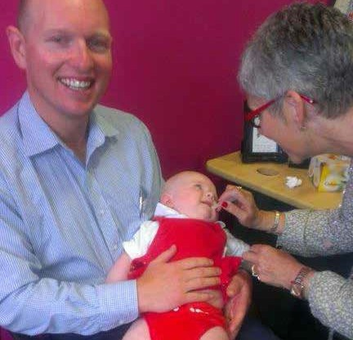
On the day of immunisation:
- Bookings are not required.
- Ensure the child being immunised is well and does not have a temperature of 38.5°C or higher.
- Please bring your Medicare card and Child Health Record book to the session.

After immunisation:
- It is important to remain at the venue for 15 minutes after immunisation for observation.
- For side effects, refer to the flyer, Common Reactions to Immunisation, which is given to you at the session.
- If reaction to a vaccine is severe or persists for periods longer than specified in the flyer, please notify your doctor or hospital.

For further enquiries regarding your child’s immunisation history, contact Australian Childhood Immunisation Register (ACIR) on 1800 653 809
or Council’s Environmental Health Department on 5261 0600.

