

2 Fraser Street Aireys Inlet Community Engagement

Findings & Recommendations Report

Wayfarer Consulting + RedRoad Consulting

www.wayfarerconsulting.com.au + www.redroad.com.au

0434 418 876 + 0409 803 063

.

# Authorship & acknowledgements

This Findings & Recommendations Report was written by Dr Andrea Cook, Director of RedRoad Consulting and Ms Helen Jennings, Director of Wayfarer Consulting, We acknowledge the generous support of many Surf Coast Shire officers, subject experts, facilitators and community members, knowing this process and this Report simply couldn’t have happened without them.

We also acknowledge the Wadawurrung, Gulidjan and Gadubanud Peoples (in the Eastern Marr/Surf Coast Shire) and the Wurundjeri Woi Wurrung (in Naarm/Melbourne). We recognise their cultures, histories, diversity and deep connection to this land and pay our respects to their Elders past, present and emerging.

**November 2022**

# Definitions

|  |  |
| --- | --- |
| Term | Definition |
| Affordable housing | Housing, including social housing, that is appropriate for the housing needs of very low, low and moderate-income households (as set by the *Victorian Planning and Environment Act 1987*). Affordable housing rent is defined as/capped at 30% of tenants’ incomes. |
| Community housing | Affordable Housing managed by not-for-profit organisations. |
| Housing provider | A registered housing agency that owns and manages community housing on smaller (provider) or larger (authority) scale. |
| Housing stress | The housing cost burden, particularly for households in the lowest 40 per cent of incomes, who are paying more than 30 per cent of gross household income on housing rental or mortgage repayments. |
| Homelessness | a person is homeless when their current living arrangement:   * is in a dwelling that is inadequate to meet their needs * has no tenure, or if their initial tenure is short and not extendable; or * does not allow control of/access to space for social relations. |
| Public housing | Social housing that is owned and/or managed by the Victorian Government. |
| Registered housing agency | A rental housing agency, registered under Part VIII of the *Housing Act 1983* and subject to regulation overseen by the Victorian Housing Registrar. |
| Social housing | Public housing (owned/managed by the Victorian State government) and housing owned, controlled or managed by a participating registered agency. People on very low to moderate incomes and people living with disability are eligible for Social Housing. Rent is capped at 30% of household income. |

(source: adapted from Hornby & Co. 2020)

# Contents

Authorship & acknowledgements ii

Definitions iii

Contents iv

Introduction & Background 1

Background 1

Our approach 3

The survey 3

The pop-up sessions 4

The Design In workshop 4

Reflections on the approach 4

A summary of findings 6

What we learned from the survey 6

What we learned from the pop ups 9

What we heard from the Design In workshop 9

Key messages 13

References 15

**01**

|  |
| --- |
| Introduction & Background |

## Background

The adoption of the Surf Coast Shire Council Affordable Accommodation Action Plan in January 2022 signalled the intention for Council to facilitate the development of social and affordable housing on suitable Council owned land.

A key opportunity for developing social and affordable housing exists at 2 Fraser Drive, Aireys Inlet (pictured below). This site is located a block east of the Great Ocean Road, behind a small shopping precinct known locally as the ‘top shops’. The total land area of 2 Fraser Drive is 6,669m2 and is made up of two sections of vacant land, existing social housing dwellings and a well-established Community Garden. The site is connected to reticulated sewerage and services (electricity, NBN, etc.).

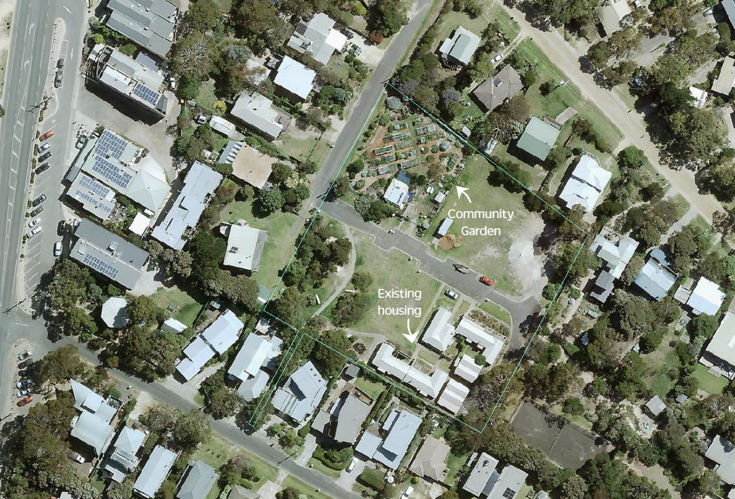

The Council embarked on the first stages of a deliberative community engagement process concerning the possibilities for social and affordable housing on this site in mid-2022[1]. This phase of consultation has comprised of the following activities:

a series of four pop up information and engagement sessions attended by around 100 people

Pop up Sessions

a three-hour deliberative workshop involving 19 community members and a range of Surf Coast Shire staff

an online survey completed by 42 Surf Coast Shire residents.

Survey

Design In workshop

The goals for the first stage engagement activities for this project were to:

* Generate participation by a diverse range of residents, community groups, education and health services, businesses, etc.
* Deepen community awareness of housing affordability issues and the role that social and affordable housing has in addressing local housing need
* Inspire increased confidence that the concept design reflects the social, environmental and heritage values and unique character of Aireys Inlet
* Positively contribute to the business case for detailed design and construction
* Contribute to the evidence-base regarding key risk and protective factors to the development of social and affordable housing in regional communities.

This Report summarises and analyses the key messages and recommendations emerging from these activities and discussions with the community.

## Our approach

We tried to design a process that allowed for different forms of participation (e.g., individual and collective; fixed timing and flexible timing, etc.). These contributed to a whole that would:



### The survey

The survey was hosted online over the course of six weeks. It was a short 10-question survey with the following questions and themes:

* Three basic demographic questions
  + How would you like to identify your gender?
  + Do you mind telling us how old you are?
  + What is your relationship to the proposed site at 2 Fraser Drive?
* Three questions concerning affordable housing provision and policy context
  + What is your experience with housing affordability and local housing needs?
  + What is your knowledge of or experience with social and affordable housing?
  + Are you aware of Council’s position on social and affordable housing?
* Three questions about the proposal itself
  + What do you know about the proposed project?
  + What do you see as being the most important factor to the success of this proposal?
  + What do you see as the greatest barrier to the success of this project?
* One open question for final comments or questions

The survey generated mainly quantitative data for these engagement findings, though it should be noted that the survey sample size does not allow for statistically valid analysis and summary. The summary will be woven together with the other (qualitative) data to provide a thematic analysis.

### The pop-up sessions

Four 2-3-hour drop in discussion sessions were held during October 2022. These pop ups happened near the site and were part of other activities (e.g. the school fete, community market).

The pop ups were informal conversations with Council staff and the consultant team, aimed at answering questions people had, assessing the appetite for the project proposal, getting an idea of people’s key concerns and generating excitement about the upcoming co-design processes. The pop up discussions were not scripted (like the survey) but open ended and related to the people engaging with the staff and the sorts of questions they had.

The pop ups also provided community members the opportunity to share their experiences of finding (or struggling to find) suitable housing in Aireys Inlet and its immediate surrounds.

The pop ups generated more qualitative data for these engagement findings.

### The Design In workshop

A ‘Design-In’ is a deliberative workshop where groups of people are guided through a range of exercises that help them think about an issue as a group. People are encouraged to listen to each other and understand different perspectives about a project, negotiating a shared ‘vision’ through deliberation.

The Design-In in this process focused on testing emerging themes and issues (from the survey and pop ups), developing some key principles for the development of the site and exploring key ideas and recommendations for action.

The Design In workshop generated more deliberative/quantitative data for these engagement findings.

## Reflections on the approach

The mixed methods approach to engagement (both in terms of the survey/drop in and workshop activities but also in terms of the questions, discussions and activities that were designed as part of each) had some positives and negatives. The following is a reflection on what worked well and what needs improvement for future engagement of this type.

The strengths of this process, as identified by participants and facilitators, included:

* The overall usefulness (rated an average of 4.4 ‘stars’ out of 5.0) and facilitation quality (also rated an average of 4.4 ‘stars’ out of 5.0) of the Design In workshop: “all was good & positive” (participant feedback on Design In)
* The session generated excitement about the next stages of the project: “I’m looking forward to the next stage of discussions or actions and architectural plans for the housing development” (participant feedback on Design In)

The weaknesses of the process included that:

* The Design In workshop was too short to address every question posed by participants. For example: “not much conversation around land ownership, the Shire sits on a valuable piece of real estate will it generate income?” (participant feedback on Design In)
* The weather for some pop ups was unfavourable and participation rates were lower than anticipated as a result
* We were unable to attract many young participants (under 25) into this project
* The conversations remained to abstract for some: “good engagement process with lots of ideas but nothing concrete” (participant feedback on Design In).

|  |
| --- |
| A summary of findings |

**02**

This section will summarise the key themes and issues emerging from the engagement activities.

## What we learned from the survey

***Q1. About you, how would you like to identify your gender?*** (67% women, 31% men and 2% preferring not to reply)

***Q2. Do you mind telling us how old you are? (***0% under 25; 17% between 25 and 44; 43% between 45 and 64 and 38% over 65. 2% preferred not to reply)

***Q3. What is your relationship to the proposed site at 2 Fraser Drive?***

Most survey respondents live in the neighbourhood (29%) or in the town (29%), as the following graph illustrates. A further 19% said they “work in and/or have an interest in social and affordable housing” and 12% are Community Garden members. Seven per cent of respondents live on Fraser Drive.

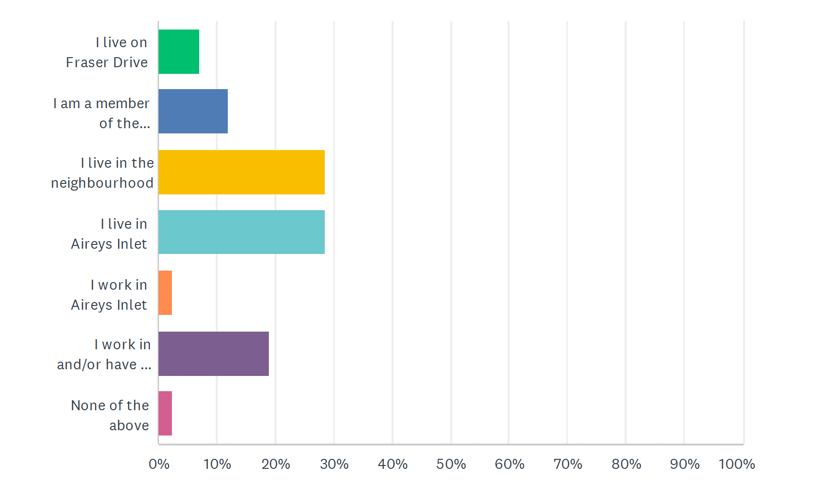

***Q4. What is your experience with housing affordability and local housing needs?***

Over half had no experience and were simply interested. Several knew a friend, family or community member who had had trouble finding affordable housing in the district (17%) or had had this trouble themselves (14%) while another 14% had accommodation but were in rental or mortgage stress.

***Q5. What is your knowledge of or experience with social and affordable housing?***

62% had theoretical knowledge about the topic while 17% had professional knowledge, working in housing and related fields. 17% had second hand experiential knowledge (e.g., had lived in neighbourhoods with social housing) and 5% has first-hand experiential knowledge (e.g. had lived in subsidised housing).

***Q6. Are you aware of Council’s position on social and affordable housing (tick as many that you are aware of)***

Council Plan and the Social Housing Policy were most familiar with over 50% ore respondents respectively. Just 26% had no knowledge of Council’s position on social and affordable housing.

***Q7. What do you know about the proposed project? (tick as many as apply)***

Again, most were aware of the various proposals, but the same number of respondents (26%) were unaware of the project.

***Q8. What do you see as being the most important factor to the success of this proposal?***

In descending order, the respondents prioritise the following:

1. Designed to provide diverse and high-quality housing to meet a range of housing needs including the needs of an older cohort and key workers
2. Designed according to Ecologically Sustainable Design principles and complementary to the local natural environment
3. The relationship and design interface with the Community Garden and surrounding neighbours
4. Designed to resolve any amenity impact on surrounding neighbours, ie traffic movement and parking
5. Designed to enhance the social and cultural heritage values of the area
6. Ongoing initiatives that help neighbours connect and build social cohesion and participation in community life

***Q9. What do you see as the greatest barrier to the success of this project?***

The strongest response to this question (43%) was related to perceived development feasibility barriers. Site constraints, planning requirements and community preferences influencing the density and social and affordable housing could limit the number of proposals received from registered housing agencies during the EOI phase of the project. A further 17% felt that overcoming/mitigating ongoing impact on amenities such as parking and traffic movement was a critical barrier. 10% felt that fostering social connection with the new tenants was going to be the biggest barrier.

***Q10. Is there anything else that we need to consider about this proposal?***

There were no strong themes identified in the comments. They ranged from strong support for the project to concerns around the lack of infrastructure to support people living in the development. A number of respondents had questions relating to who could live in the development and whether it would be suitable for older people, single people or people with a disability.

## What we learned from the pop ups

A range of concerns and considerations were raised at the pop ups which were carried forward into the Design In process. These included:

* Lack of essential infrastructure, facilities and services within the township to support people living in social housing.
* Lack of work/transport to work in the area
* Council should not hand over ownership of the land as it is valuable
* Council should deal with the bigger problem of empty houses and AirBnB

***Can’t get 12-month rentals – have to camp over summer with two small children because I can only get 8-9-month rentals***

**Participant comment at pop up**

**“**

* This land was left by Isla Stamp for housing for older people *(not accurate)*
* The development will look ‘urban’ or not be in keeping with the surrounds
* This might not happen and it is very much needed: it has been suggested in the past but never happened.

## What we heard from the Design In workshop

The first conversation/deliberation that the workshop participants had was to explore was concerns and opportunities related to the project, which are summarised below:

|  |  |
| --- | --- |
| Opportunities | Constraints |
| * Build something that people wanted to live in as they walk past * To create a showcase project * Sustainable and recyclable * Visit the question of density * Viability of the town and bring more people/ keep more people * Expand the proposal by linking with other sites * Intergenerational opportunities * Big build funding * Learn from previous experiences (e.g., to do better with management/maintenance) * Modular housing * Accessibility * Council owns the land * “Create a village within the village” | * Defining who’s at most need (women over 40, for example) and who needs housing * Tenancy and management * Access and parking and traffic * Perception and objections from wider community * Too many planning restrictions * Loss of diversity in town – this is an opportunity as well (to mitigate that loss * Noise? * Maintenance ongoing * Potential density (can be an opportunity too) * Accessibility * Landscaping that fits in to neighbourhood (also an opportunity) |

Many of the opportunities and constraints were described as ‘double edged swords’ where there could be either positive or negative outcomes, depending on the design quality. For example, density was seen as something to both experiment and be bold with but also take care with so as to not overwhelm the neighbourhood, other people’s aspects and quiet enjoyment of home, etc.

Given this, the group’s development of shared ‘guiding principles’ for the project is especially important as these principles will inform the decision-making processes of developing the site:

1. COURAGE. The project should (carefully) explore the opportunities afforded by increasing the density
2. BEAUTY. The project should ensure the building/s look beautiful – a place people want to live in and a chance to be ‘showcase’ development
3. QUALITY. The project should ensure a high quality and sustainable build – 7star+
4. FUNCTION. The project needs to be fit for purpose and fit in with the town and environment
5. INCLUSIVITY. The process and build need to be inclusive, integrated and appropriate for the needs of residents.

In the final discussion of the workshop, groups were tasked with developing ideas for action. This was a challenging conversation given the stage of the project but the following are some of the ideas that the participants developed together:

**Idea 1**

Help people understand what different densities can look like (and that they can be beautiful) – differentiating between height and density. Do demonstrations/case studies/illustrations/video and other media to support this learning

**The Issues it addresses (and how)?**

Exploring opportunities and innovating with density (and showing this to people so they can understand)

**Who will champion this idea?**

CAG advised by different agencies and groups

**Other details**

Need to know about the capacities of housing providers

**Idea 2**

Build housing that is flexible in design to allow a range of housing needs – building community within space but also something that engages with the street too. Sharing some facilities (e.g., laundry)

**The Issue this addresses**

We don’t know who will move in – now or in the future – build a good green space – balance between the place and the broader community (so it looks in and out). Opportunity to use less space – and saves money

**Who will champion this idea?**

Aireys Refugee group; Local businesses

**Other details**

* Refugee housing
* Workers housing – possible temporary housing
* Needs outdoor play space – if there are kids living/ visiting - there are great examples in Sweden – needs to look out onto where the kids are playing so plenty of observation of children playing
* Almost like a shared house approach
* Also needs community development to build a sense of community
* Look out onto the community garden

**Idea 3**

Define quality assurance/standards for the project re: fixtures/fittings/ quality/ maintenance. ‘Resolved aesthetic’ re the look of the buildings and how it fits with surrounds e.g. landscaping – learn from existing examples, be a benchmark, be beautiful, great, a vision for what is possible

**The Issues it addresses (and how)?**

Quality and beauty of the construction as well as inclusivity (co-design)

**Who will champion this idea?**

CAG advised by different agencies and groups; tenants/users

E.g. learn more about the region

**Other details**

* Regulatory framework

**Idea 4**

Tenancy and management – really understanding who our key workers are.

* Diversity including refugees
* Diversity framework
* Locals-people living here
* Choosing the right RHA – operates here, proven track record (if things go pear-shaped - ownership/ management goes back to Council)

Scope/ brief of EOI has to point to the right RHA. Clear assessment criteria.

**The Issues it addresses (and how)?**

Inclusion: getting the right balance of tenants (diversity, local)

**Who will champion this idea?**

Council, CAG, community input to getting the criteria and brief right

**Other details**

* EOI objectives prior to EOI going out

|  |
| --- |
| Key messages |

**03**

The process needs a **long range view**. It needs to be ecologically sustainable and employ robust building techniques so that the property will last 50 years. It also needs to think about the future needs of the community: the process should identify who needs housing now but also be thinking about who may need housing in the future.

***Lots of older people in Aireys will need suitable housing in the future***

**Participant comment at pop up**

**“**

The process for developing the site needs to be **inclusive of different needs and viewpoints**, especially different tenant needs and viewpoints. For example, accessibility for those with disability will consist of both access to the physical buildings when finished as well as to the processes of co-design and decision making in the development phase.

**Understanding and meeting local need** was raised as a critical issue in all engagement activities. Indeed, the two concepts -- ‘local’ and ‘need’ -- were discussed and questioned and assessed as central to the project and to housing in Aireys Inlet more broadly. The housing waiting list (over 600 for the region) needs more analysis as it is unclear who on the list is a ‘local’ wanting to stay (or a ‘local’ who has had to leave the area because of housing costs, as the following quote illustrates).

***I am homeless and would love to move back to Aireys***

**Participant comment at pop up**

**“**

This project will be judged by the outcome. It must fit into and improve the local area. The EOI must clearly articulate the community understanding of the project. It will need to include the requirement for **highly sustainable and beautiful buildings that respond to the local environment.** These buildings will need good maintenance and management and be supported by landscaping.

*A private company with little connection to the community is less likely to have any interest in meeting the unique character of Aireys Inlet*

**Survey respondent**

**“**

The need to **manage objections and perceptions** of community housing will be essential throughout the project. Promoting the importance of the project to help maintain the viability of the town and to meet a pressing housing need will be an ongoing activity.

***Housing is an urgent requirement in the area before we lose more valuable families from the area. The housing should provide privacy & dignity.***

**Survey respondent**

**“**

This project provides an opportunity to **showcase a housing response** that can serve as a demonstration project for how social, affordable and community housing can be. It may challenge ideas of density, sustainability and character to look for innovative solutions to housing the community.

This project has been under consideration for many years. One community member indicated that the **project needs to happen as a matter of urgency.**

***This is a fantastic proposal, thoughtfully done. I wish you all the best and I am happy to see an increase in affordable, accessible social housing in my neighbourhood.***

**Survey respondent**

**“**

# References

Hornsby & Co. for CHIA and MAV. (2020). Affordable Housing Agreements: Advice for local government and community housing organisations*.* [http://www.mav.asn.au/__data/assets/pdf_file/0010/24796/Affordable-Housing-Agreements_DIGITAL.pdf.](http://www.mav.asn.au/__data/assets/pdf_file/0010/24796/Affordable-Housing-Agreements_DIGITAL.pdf)

1. these engagements also build upon previous conversations with the community about this site and about the strategic goals for Aireys Inlet (e.g. the 2015 Structure Plan, etc.)