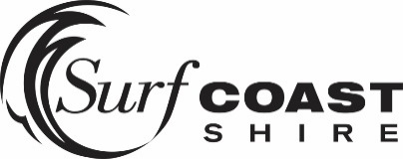
Media release
8 March 2018

Nominations open for Surf Coast Youth Awards

People are encouraged to nominate someone they know for the 2018 Surf Coast Youth Awards, which will recognise the achievements and contributions of young people.

The annual awards are a celebration of young people who live, work, study or recreate in the Surf Coast. People can nominate across five categories – Leadership, Community, Music, Arts and Sport.

“The Surf Coast is packed with young people who are doing great things in our community,” Cr Martin Duke said.

“It’s important that we acknowledge their outstanding contributions and celebrate their achievements, with the youth awards a perfect opportunity to do so.”

People aged between 12 and 25 can be nominated for an award.

“Last year the quality of nominations was exceptional, and we expect the same this year,” Cr Duke said.

“The awards showcase how passionate and dedicated our youth are, and how they are setting an example for both young and old in our community.”

Last year’s joint Community winner Dan Smith went on to receive the Young Citizen of the Year at the 2018 Australia Day Awards. Dan was acknowledged for his service to Jan Juc Surf Life Saving Club, Bellbrae CFA and Torquay Marine Rescue Service.
Nominations for the 2018 Surf Coast Youth Awards close Monday 16 April at 9am. To nominate, visit the Surf Coast Youth Facebook page www.facebook.com/surfcoastyouth.

Winners will be announced at the 2018 Surf Coast Youth Awards, to be held in Council Chambers on Saturday 21 April from 4pm. The awards are supported by a Victorian Government grant and will be held as part of Victorian Youth Week 2018.

