30 July 2019

Surf Coast Arts Trail: Let’s get digital
The 2019 Surf Coast Arts Trail will be at people’s fingertips in more ways than one this year, with the popular event launching an online map.
The digital map has been introduced to help people explore the trail on 10 and 11 August. Now in its eighth year, the Arts Trail will feature more than 160 artists across 54 venues – from Winchelsea to Moggs Creek, and Wurdiboluc to Jan Juc.
The map is divided into four geographical zones, while there is also an opportunity to choose which art mediums you’re interested in – painting and illustration, photography, multimedia, fibre arts and crafts, ceramics, glass and wood, and installation and performance.
The digital guide complements the existing printed map. Surf Coast Shire Council Mayor Rose Hodge encouraged people to start planning their Trail weekend.
“With many artists only opening their doors to the public during the Arts Trail, the weekend provides a rare opportunity for the public to see artists and studios demonstrating their crafts,” she said.

“This event is a highlight on the calendar and is the perfect way to explore the coast and hinterland.”
The digital map can be accessed on most iPhones by pointing your camera at the code to open the map. Most Android phones require a QR code reader app, which can be downloaded via free apps available in the App Store or Google Play.
The 2019 Surf Coast Arts Trail will run the weekend of 10 and 11 August, from 10am to 4pm each day. For more information and a link to the digital map, visit www.surfcoast.vic.gov.au/artstrail.
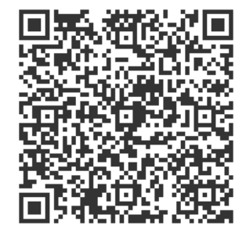
Not for publication:
For further information
Kate Fowles - Communications Officer
5261 0564 0428 436 489

