Surf Coast Shire

Domestic Animal Management Plan

2012-2016
(Revised April 2014)

Domestic Animal Management Plans 4
EXECUTIVE SUMMARY 5
1.0 INTRODUCTION 6
1.1 OUR SHIRE 6
1.2 PURPOSE 6
1.3 MISSION STATEMENT 6
1.4 CONSULTATION PROCESS 6
2.0 DOMESTIC ANIMAL PLAN REVIEW 2008 – 2012 7
3.0 TRAINING OF AUTHORISED OFFICERS 9
3.1 CONTEXT 9
3.2 CURRENT AND PLANNED TRAINING TABLE 10
4.0 REGISTRATION AND IDENTIFICATION 11
4.1 CURRENT SITUATION 11
4.2 ACTION PLAN – REGISTRATION & IDENTIFICATION 13
Objective 1: 13
5.0 NUISANCE 15
5.1 CURRENT SITUATION 15
5.2 ACTION PLAN – NUISANCE 18
Objective 1: 18
Objective 2: 19
Objective 3: 19
6.0 DOG ATTACKS 20
6.1 CURRENT SITUATION 20
6.2 ACTION PLAN – DOG ATTACKS 22
Objective 1: 22
Objective 2: 23
7.0 DANGEROUS, MENACING AND RESTRICTED BREED DOGS 24
7.1 CURRENT SITUATION 24
7.2 ACTION PLAN – DANGEROUS, MENACING AND RESTRICTED BREED DOGS 25
Objective 1: 25
Objective 2: 26
8.0 OVERPOPULATION AND HIGH EUTHANASIA 27
8.1 CURRENT SITUATION 27
8.2 ACTION PLAN - OVERPOPULATION AND HIGH EUTHANASIA 28
Objective 1: 28
9.0 DOMESTIC ANIMAL BUSINESSES 29
9.1 CURRENT SITUATION 29
9.2 ACTION PLAN - DOMESTIC ANIMAL BUSINESSES 30
Objective 1: 30
10.0 OTHER MATTERS 31
10.1 CURRENT SITUATION 31
10.2 ACTION PLAN – OTHER MATTERS 32
Objective 1: 32
Objective 2: 32
11.0 ANNUAL REVIEW OF PLAN AND ANNUAL REPORTING 34
11.1 ACTION PLAN – ANNUAL REVIEW OF PLAN AND ANNUAL REPORTING 34
Objective 1: 34
APPENDIX 35
Surf Coast Shire’s Community Local Law No.1(animal related sections) 34
Disater planning for Domestci Animals
Dog regulation maps

Domestic Animal Management Plans

Under Section 68A of the Domestic Animals Act 1994, every Council must prepare a domestic animal management plan, as follows:
68A Councils to prepare domestic animal management plans
(1) Every Council must, in consultation with the Secretary (of the Department of Primary Industries), prepare at 4 year intervals a domestic animal management plan.
(2) A domestic animal management plan prepared by a Council must—
(a) set out a method for evaluating whether the animal control services provided by the Council in its municipal district are adequate to give effect to the requirements of this Act and the regulations; and
(b) outline programs for the training of authorised officers to ensure that they can properly administer and enforce the requirements of this Act in the Council's municipal district; and
(c) outline programs, services and strategies which the Council intends to pursue in its municipal district—
(i) to promote and encourage the responsible ownership of dogs and cats; and
(ii) to ensure that people comply with this Act, the regulations and any related legislation; and
(iii) to minimise the risk of attacks by dogs on people and animals; and
(iv) to address any over-population and high euthanasia rates for dogs and cats; and
(v) to encourage the registration and identification of dogs and cats; and
(vi) to minimise the potential for dogs and cats to create a nuisance; and
(vii) to effectively identify all dangerous dogs, menacing dogs and restricted breed dogs in that district and to ensure that those dogs are kept in compliance with this Act and the regulations; and
(d) provide for the review of existing orders made under this Act and local laws that relate to the Council's municipal district with a view to determining whether further orders or local laws dealing with the management of dogs and cats in the municipal district are desirable; and
(e) provide for the review of any other matters related to the management of dogs and cats in the Council's municipal district that it thinks necessary; and
(f) provide for the periodic evaluation of any program, service, strategy or review outlined under the plan.
(3) Every Council must—
(a) review its domestic animal management plan annually and, if appropriate, amend the plan; and
(b) provide the Secretary with a copy of the plan and any amendments to the plan; and
(c) publish an evaluation of its implementation of the plan in its annual report.

EXECUTIVE SUMMARY
Surf Coast Shire developed its first Domestic Animal Management Plan (DAMP) for 2008 to 2012 in accordance with the Domestic Animals Act 1994, (the Act). This Plan reviews the actions and planning for Surf Coast Shire to set the direction for domestic animal management for the coming four (4) years and to meet the requirements under the Act.

The plan details programs and actions to assist in implementing the mission statement of this plan. The plan has been developed with assistance from a broad range of stakeholders that seek to implement a balanced approach to domestic animal management in the Surf Coast Shire.

The plan identifies a range of actions for animal management. The implementation of these actions gives Council the opportunity to monitor the progress of actions and arrange further improvements to promote and facilitate responsible animal management programs on a regular basis.

Council is committed to providing a high standard of animal management in accordance with legislative requirements. The objectives of the plan are to:
- Ensure Animal Management Officers (AMOs) are appropriately trained in all aspects of responsible animal management;
- Encourage responsible dog and cat ownership
- Reduce public and environmental nuisance caused by dogs and cats
- Promote the effective management of dogs and cats
- Effectively identify all dangerous dogs, menacing dogs and restricted breed dogs in the Shire
- Minimise the risk of attacks by dogs on people and animals
- Address any over population and high euthanasia rates of dogs and cats
- Provide welfare for pets during periods of emergency

There is an increasing public view that punitive enforcement of laws alone will not result in lasting voluntary changes in behaviour. Therefore, enforcement of the Act and Local Laws should be balanced with media and public education material for responsible animal management.
There is now considerable evidence to support the benefits of owning pets. Accordingly, Surf Coast Shire recognises that companion animals are part of the community, contributing to the quality of life for its residents.
The strategies within this plan have been developed to provide Council with a sound foundation from which it can build plan and co-ordinate sound animal management and ensure that future decisions meet the needs of the community.
In this progressively changing environment, it is essential that Council take a strategic approach to managing domestic pets.

- INTRODUCTION

1.1 OUR SHIRE
The Surf Coast Shire is located in south west Victoria, with its main township Torquay which is 21 kilometres south of Geelong and 120 kilometres from Melbourne. It covers an area of 1562 square kilometres with some 55 kilometres of coastline defining its southern boundary. The world famous Great Ocean Road begins in Torquay and traverses the Shire through to its western border.
The shire is strongly influenced by physical and topographical features, which impact on urban development and land use management. It is characterised by a diverse range of environments including rugged coastline, dense native forests and rolling, rural plains.
The southern part of the shire is characterised by a linear pattern of coastal townships along the Great Ocean Road, including Torquay, Anglesea, Aireys Inlet, Fairhaven and Lorne. With the exception of Torquay, these towns are sited on the coastal fringe of the Otway Ranges and are surrounded by substantial tracts of forested public land.
North of the Otway is a large and distinctive rural community including the townships of Winchelsea, Deans Marsh and Moriac. The town of Torquay, located at the eastern end of the Shire, is the main population township within the centre of the municipality. Torquay’s beachside is a significant feature and its proximity to Geelong and Melbourne make it an attractive residential location for those working in these major areas.
Council has a permanent population of 26,493 (2011 Census) but has over 40% of its property assessment owned by people who do not live permanently within the Shire. The population of Council swells significantly of weekends and during the summer period.

1.2 PURPOSE
This plan has been developed to ensure Council meets its obligations under the provisions of Domestic Animals Act 1994 in relation to Domestic Animal Management Plans.
The plan sets out a method for evaluating whether the animal control services provided by Surf Coast Shire is adequate to give effect to the requirements of the Act and the regulations; and outline programs for the training of authorised officers to ensure that they can properly administer and enforce the requirements of the Act in Surf Coast Shire.
Such programs, services and strategies will promote and encourage the responsible ownership of dogs and cats and ensure that people comply with the Act, regulations and Local Law. Through education and services this will minimise the risk of attacks by dogs on people and animals and address any over-population of dogs and cats, encourage the registration and identification and minimise the potential for dogs and cats to cause a nuisance.
Identify all declared dangerous dogs, declared menacing dogs and restricted breed dogs within Surf Coast Shire and to ensure that those dogs are kept in compliance with the Act and regulations.

1.3 MISSION STATEMENT
To encourage and facilitate responsible pet ownership through education and innovative strategies that allows people and pets to integrate safely and harmoniously within Surf Coast Shire.

1.4 CONSULTATION PROCESS
The plan was developed in consultation with Surf Coast Shire Councillors, Surf Coast Shire’s Executive Management Team, Team Leader – Local Laws, Local Laws Team, Surf Coast community, Boarding Establishments and Pet Businesses.
2.0 DOMESTIC ANIMAL PLAN REVIEW 2008 – 2012
The table below denotes reviews the outcome for the actions in the DAMP 2008 – 2012.

Sec | Program / Service Initiative | Action | Completed / Outcome
9.1 | Conduct Animal Management Officer Training. | Arrange attendance at all Bureau of Animal Welfare Training Seminars.  Animal management handling and training.  Training programs with other Councils. | All Local Laws Officers attended Bureau of Animal welfare Training Sessions including, additional specific animal training programs.  Two Local Laws Officers have completed a Certificate IV – Government Statutory Compliance or Certificate IV – Animal Control or Regulation.  Firearms training, with three Local Laws Officers licenced.
9.2 | Promote and Encourage responsible Pet Ownership. | Distribute pet brochures throughout Surf Coast Shire. Display pet educational material at Surf Coast Civic Centre and maintain and up to date information on Council’s website. Encourage re-housing practices, where pet owners are unable to care for their pet. Enforce Council Local Laws that require all people in charge of an animal whilst on Council land, a roadway or public place, have in their possession a bag to container which can be used for the collection of that animals excrement. | Brochures have been produced and distributed from Civic Centre and annual Microchipping Days.  Information listed on Council’s web site.  Extensive media releases during life of Plan  Agreement with GAWS to rehouse all unclaimed pets where possible.
9.3 | Ensure compliance with Act and Regulations. | Conduct an annual doorknock to identify and register all dogs and cats. Provide 24 hour 7 day per week response service. Enforce microchip requirements for all new pet registrations. Monitor compliance of all beaches in relation to dogs. | Doorknocks have been conducted each year to identify unregistered dogs and cats.  After hours service has continued dealing with all pet related issues.  Council will only accept dog and cat registrations that show proof of micro chipping.  All beaches are regularly patrolled.
9.4 | Minimise the risk of dog attacks. | Monitor and review dog off-leash areas. Conduct regular patrols of all council parks, beaches and reserves.  Ensure properties have suitable fencing to securely contain dogs. | All council parks, beaches and reserves have been regularly checked by staff.  Notices have been issued to properties for failing to provide adequate fencing to secure dogs.

Sec | Program / Service Initiative | Action | Completed / Outcome
9.5 | Address over population and high euthanasia of dogs and cats. | Encourage re-housing and adoption of unwanted dogs and cats. Hire of cat cages for trapping of feral cats. | Cat traps are readily available for hire. Unclaimed dogs and cats that pass assessments have been rehoused.
9.6 | Encourage the registration and identification of dogs and cats. | Annual mail out of dog/cat registration renewal forms. Mail out reminder notices for unpaid animal registrations. | Registration renewal forms sent out mid February each year.  Final Reminder notices sent out mid May each year.  Regular media releases encouraging pet registration, web site notice referring to pet registration.
9.7 | Minimise the potential for dogs and cats to create a nuisance. | Encourage the use of cat enclosures. Hire of anti-barking collars. Pet owners to carry dog tidy bags when walking dogs. | In cases of cat wandering issues officers have promoted the installation of cat enclosures.  Letter box drops of brochures for reports of wandering cats. Cat cage hire available.  Anti barking collars readily available for hire.
9.8 | Dangerous Dogs, Menacing Dogs and Restricted Breed Dogs. | Programmed inspections of registered properties housing Restricted, Declared or Menacing Dogs. Ensure information is readily available that clearly outlines restrictions for the above dogs. | All properties housing RBDs, Dangerous/Menacing dogs are audited.
9.9 | Review existing orders made under the Act and Local Laws. | Restrict the number of dogs and cats permitted on a property without a permit. Review in accordance with GORCC all beaches and the necessity to allow dogs in specific locations. | 2 dogs and 2 cats permitted, an excess animal permit is available to residents to keep more than above providing relevant conditions are accepted with appropriate housing, one dog and one cat permitted in flats and units.

3.0 TRAINING OF AUTHORISED OFFICERS
The purpose of this section is to ensure all animal management officers are skilled and appropriately trained to deliver our services and programs under Section 68A(2)(b) of the Domestic Animals Act 1994.

3.1 CONTEXT
There are four (4) field officers within the Local Laws Unit that deal with animal management issues as part of their daily work activity. In addition to animal management all officers also undertake Local Laws and parking enforcement duties. The organisational structure is set out in the chart below.

Director Planning and Environment
Kate Sullivan

Manager of Planning and Environment
Brydon King
3.2 CURRENT AND PLANNED TRAINING TABLE
Casual Local Laws Officers
3x Casual Officers
Local Laws Officers
Tony Rolfs
John Bauer
Trevor Doueal
Robert Pitcher
Local Laws Administration Support
2x Part Time Officers
School Crossing Supervisors
Coordinator of Development Compliance and Local Laws
Andrew Hewitt
Team Leader Local Laws
VACANT (as at 3/7/2014)

Authorised Officer Training | Current (2012) | Planned
Industry training – animal handling, animal assessment, statement taking, prosecution, computer skills, firearm, seminars. | All staff have participated in OH&S generic training, Charter of Human Rights training, internal IT systems, seminars held by the Bureau of Animal Welfare, firearms training. | Annually, if available
OH&S training – dealing with aggressive customers | All staff have attended annual training sessions for dealing with difficult people and conflict resolution. The training was conducted by Victoria Police negotiators. | Annually
Bureau of Animal Welfare – training and information days | All Local Laws Officers have attended training and information sessions from 2008 to 2012. | As listed by Bureau of Animal Welfare
Induction program for new staff | All staff as part of their induction process is taken through a training program that covers such issues as, manual handling, use of animal specific equipment, procedures, animal diseases, dog/cat behaviour, aggressive dogs, feral cats and body language. | All new staff
Authorised Officer Training – Additional  Cert IV - Animal Control | 2 Local Laws Officers to complete | 2015
Industry training – time management | Staff attend in-house time management training | Annually
Animal handling training provided by Accredited Trainer | All staff attended “hands on” animal handling training that deals with, seizing dogs, aggressive dogs, behavioural issues, cat trapping, and handling cats. | Training will be provided annually
4WD Training | All Local Laws Officers will undergo 4WD training to assist them while fulfilling their beach patrols. | Annually

4.0 REGISTRATION AND IDENTIFICATION

Encourage the registration and identification of dogs and cats under Section 68A(2)(c)(v) of the Domestic Animals Act 1994.

4.1 CURRENT SITUATION
Our Current Data

 | De sexed | Micro chipped | Pensioner | Full Fee | Total
Cats | 801 | 539 | 172 | - | 826
Dogs | 3736 | 3558 | 641 |  | 4911
Cats | 97% | 65% | 21%
Dogs | 76% | 72% | 13%

Our Current Orders, Local Laws, Council Policies and Procedures
- Domestic Animals Act 1994 - Compulsory de-sexing of all cats over the age of 3 months.
- Surf Coast Shire Community Amenity Local Law – Designated ‘Off Leash Areas’
- Surf Coast Shire Community Amenity Local Law – Designated ‘Time Share Areas’ where dogs are not allowed and during particular periods allowed off leash.
- Surf Coast Shire Community Amenity Local Law – Designated ‘No Dogs Allowed’ areas.
- Surf Coast Shire Community Amenity Local Law – limitation of two (2) dogs and (2) cats in residential areas without a permit.
- Domestic Animals Act 1994 Order made 8 March 2001 - All areas except rural areas 8pm to 6am– Cat Curfew.

Our Current Procedures
- Work Instruction 102 – Livestock Control
- Work Instruction 104 – Dangerous Dog & Dog Attack
- Work Instruction 110 – Attending Call-Outs After Hours
- Work Instruction 120 – Stress Management
- Work Instruction 121 – Personal Safety
- Work Instruction 123 – Handling of Firearms
- Work Instruction 126 – Nuisance Barking Dogs

Our Current Education/Promotion Activities
- Media releases promoting pet registration in all local newspapers and on Council’s website.
- Free registration of dogs and cats under the age of 3 months for first year of registration.
- Microchipping Days – where we offer discounted microchipping and process registration at two different locations on weekends.
- Online application forms, pamphlets, and information through Councils webpage.
- Citronella Collar hire.
- Educational Information online - dog maps, barking dog booklet, Surf Coast Shires Disaster Plan.
- Show bag hand out with new registrations – Customer Service.

Our Current Compliance Activities
- Pet Registrations - Annual mail out of dog & cat registration renewal forms.
- Compulsory microchipping of dogs and cats for first registration.
- Conduct an annual doorknock and follow up of non-renewal of registrations.
- Microchipping Days – discounted microchip implanting.

Summary
Surf Coast Shire currently has a total of 6,743 registered dogs and cats. The municipality is located in South West Victoria, covering an area of 1562 square kilometres with 55 kilometres of coastline. During the next four (4) years there will be growth, subsequently resulting in additional work for Council’s Local Laws Department. Major consideration has been given towards business planning for the future.

4.2 ACTION PLAN – REGISTRATION & IDENTIFICATION

Objective 1: To ensure all dogs and cats which are over the age of three months which reside within the municipality are declared and registered with the Surf Coast Shire and ensure that they are either implanted with a microchip.

Activity | When | Evaluation
Conduct an annual doorknock and follow up outstanding registrations to gain compliance. | Annually  (October) | Assists the public and gives them every opportunity to comply. Increases animal registration and ability to reunite missing animals.
Media releases through Council’s Communication Department, published in the internal Council magazine notifying residents of the requirements relating to registration requirements, including renewal date and animals to which a reduced fee applies. Publish articles in local paper prior to start of renewal period. | Annually (Feb) | Raises awareness relating to responsible ownership.  Assists AMOs ensuring strays can be returned as soon as collected.  Promotes compliance.
Microchipping Day | Annually (March) | Provide discounted micro chipping, veterinary attention and animal ownership information and advice.
Mail out of registration renewal forms. | Annually (Feb) | Provides residents every opportunity to register they pets prior to 10 April.
Mail out of final notices for registration renewals. | Annually (May) | Increases registered number of dogs/cats
Domestic Animals Act 1994 - Compulsory micro-chipping of dogs and cats prior to registration. | Ongoing | Promotes recovery rate.  Assists AMOs with identification.
Accessibility to online registration/renewal, and a range of registration payment methods – credit card, BPay, cheque. | Ongoing | Convenience for public.
Use Council’s website to provide information to residents on when registration is due, how and where to register, fee structure, registration form, what information they need to provide (e.g. microchipping, desexing certificates), letting Council know they are no longer the owner, have changed address or the pet is deceased. Highlight renewal period on website in March and April. | Annually (Feb) | Promotes compliance.
Microchipping Scanners | Ongoing | Ensure all AMOs are equipped with portable microchip scanners.
MAV Desexing Vouchers | Annually | Investigate subsidy desexing scheme through MAV providing vouchers that will be accepted at Local Vets.
Free transfer registration | Annual | Investigate free dog & cat transfer of registration when relocating to Surf Coast Shire, if the animals are currently registered with another Council.
Review Local Law No 1 | 14/15 | - Investigate in relation to the keeping of cats and confirm whether increasing of number of cats per property from 2 to 4 should be undertaken.
5.0 NUISANCE
Minimise the potential nuisance that may be caused by dogs or cats under Section 68A(2)(c)(vi) of the Domestic Animals Act 1994.

5.1 CURRENT SITUATION
Our current data

Activity | 2009 | 2012
Pick up constrained dog | 61 | 256
Dogs reported wandering at large | 75 | 391
Barking dog complaints | 32 | 87
Pick up constrained cat | 2 | 21
Cat nuisance | 6 | 35
Cat not confined to premises | 6 | 35
Dog attack | 16 | 48

Our Current Orders, Local Laws, Council Policies and Procedures
- Domestic Animals Act 1994 - Compulsory de-sexing of all cats over the age of 3 months.
- Surf Coast Shire Community Amenity Local Law – Designated ‘Off Leash Areas’
- Surf Coast Shire Community Amenity Local Law – Designated ‘Time Share Areas’ where dogs are not allowed and during particular periods allowed off leash.
- Surf Coast Shire Community Amenity Local Law – Designated ‘No Dogs Allowed’ areas.
- Surf Coast Shire Community Amenity Local Law – limitation of two (2) dogs and (2) cats in residential areas without a permit.
- Domestic Animals Act 1994 Order made 8 March 2001 - All areas except rural areas 8pm to 6am– Cat Curfew.– Cat Curfew.

Our Current Procedures
- Work Instruction 102 – Livestock Control
- Work Instruction 104 – Dangerous Dog & Dog Attack
- Work Instruction 110 – Attending Call-Outs After Hours
- Work Instruction 120 – Stress Management
- Work Instruction 121 – Personal Safety
- Work Instruction 123 – Handling of Firearms
- Work Instruction 126 – Nuisance Barking Dogs
Surf Coast Shire’s Community Amenity Local Law
Refer Appendix A

Our Current Education/Promotion Activities
- Notification to residents of any fireworks displays.
- Provide educational material through letterbox drops and advocate responsible ownership relating to confinement of cats and dogs and animal nuisance.
- Provide information on Council’s web site to report nuisance animal complaints.
- Media releases – Animal Nuisance.

Our Current Compliance Activities
- Prosecute pet owners where applicable, relating to breaches of Council’s Local Law and non-compliance with the Domestic Animals Act 1994.
- Actively deal with barking dog complaints and take enforcement action where applicable;
- Issue ‘Warning Notices’ and ‘Notices to Comply.’
- Issue Infringement Notices.
- Programmed patrols of areas.
- Provide cat and dog traps.
- Provide 24 hour service for the collection of dogs, nuisance animals, stray animals and dog attacks.
- Annual inspection of all excess animal permit holders.
- Unscheduled inspections of all declared Dangerous, Menacing and Restricted Breeds dogs.

Summary
The Surf Coast Shire’s current process relating to nuisance animals is received well by the community, through the hiring of cat traps and citronella collars. Council has made orders relating to the desexing of all cats prior to registration, restricting cats to a curfew and the requirement to have all dogs on a lead, chain or cord while in specific locations, prohibit dogs in some locations and provide time share locations.
Effective control of dogs in public places, reduces the likelihood of dog attacks, enables residents to comfortably enjoy these open spaces without the fear of dog attack and ensures public safety. The order relating to the de-sexing of cats prior to registrations, encourages responsible ownership, prevents potential feral and unwanted litters. The cat curfew was introduced in 2007 and has proved effective by reducing nuisance complaints of cat’s trespassing on private properties.

5.2 ACTION PLAN – NUISANCE
Objective 1: To provide readily accessible information to the public relating to animal nuisance (Education/Promotion Activities).

Activity | When | Evaluation
Letterbox drop – brochures/factsheets/Bureau of Animal Welfare regarding nuisance activities. | Ongoing | Informs and educates the public.
Relevant Signage and Litter bins/bags around the Municipality. | Ongoing | Promotes responsible ownership.  Assist public.  Educated the public.
Educate the community to keep cats and dogs secure to their properties. | Ongoing | Doorknocks by AMOs.  Letter drops.  Media releases.
Provide information on Council’s web site to report nuisance animal complaints. | Ongoing | Easily accessible for public.  Assists AMO’s.
Media releases – responsible ownership/nuisance activities. | Quarterly | Informs and educated the public.
Advise residents using cat traps for trespassing cats that they must immediately notify Council to collect the cat. | Ongoing | Information issued with cat trap hire application and followed up with a conversation when hiring the trap.
Promote and inform residents of the designated off-leash locations and the requirements in these areas. | Ongoing | Media releases web page and face to face contact at the civic centre.
Return stray dogs to owners. | Ongoing | AMO to make initial contact with owner and give opportunity to collect the impounded dog as soon as possible, restricting the likelihood of dog being taken to pound.
Review Surf Coast Shire Dog Regulations | Annually | Identify and implement necessary amendments/additions.
Review cat curfew and application | 14/15 | Identify any necessary changes to cat curfew

Objective 2: To provide readily accessible information to the public relating to animal nuisance. Promote responsible ownership through education and promotional activities (Barking Dogs).

Activity | When | Evaluation
Provide information on the causes of excessive barking, including: separation anxiety, boredom, external stimuli, traffic, other dogs barking, cats trespassing and territorialism. | When a barking dog complaint is received. | Provides dog owner information to prevent barking.  Promotes good neighbourly relations.
Encourage owners of barking dogs to seek advice from Council/professional dog trainer/animal behaviourist on how to reduce their dog’s barking. | When a barking dog complaint is received. | Provides dog owner information to prevent barking.  Promotes good neighbourly relations.
Hiring of Citronella Collars. | Ongoing | Reduces the nuisance.

Objective 3: To provide readily accessible information to the public relating to animal nuisance, promote responsible ownership through education and promotional activities (Dog Excrement).

Activity | When | Evaluation
Advise dog owners of legal requirements relating to cleaning up dog excrement by distributing education material on Council website and handouts. | Quarterly | Educated public  Reduces the complaints
New Registration Show Bags- Provide free dog excrement bags. | Ongoing | Assists public  Convenience
Provide dog excrement bag dispensers and disposal bins in parks/beaches to encourage owners/person in charge of animal to clean up the animal’s excrement. | Ongoing | Assists public  Convenience  Reduces excrement left in parks/beaches
Audio Sounds Device System | Ongoing | Assists AMOs with their investigation.

6.0 DOG ATTACKS
Minimise the risk of dog attacks throughout Surf Coast Shire under Section 68A(2)(c)(iii) of the Domestic Animals Act 1994.

6.1 CURRENT SITUATION
Our Current Data
Year to date, the Surf Coast Shire has brought two (2) people before the Court in relation to section 29 breaches of the Domestic Animals Act 1994. All complaints are treated seriously and Council continually advocates that dog owners will be dealt with through enforcement. This is received well; Surf Coast Shire has a consistent approach towards bringing dog owners before the Court relating to dog attack offences.
Council on occasion may exercise it discretionary power to destroy dogs in certain circumstances, impose a Dangerous Dog declaration or a Menacing Dog declaration.

Our Current Orders, Local Laws, Council Policies and Procedures
- Domestic Animals Act 1994 - Compulsory de-sexing of all cats over the age of 3 months.
- Surf Coast Shire Community Amenity Local Law – Designated ‘Off Leash Areas’
- Surf Coast Shire Community Amenity Local Law – Designated ‘Time Share Areas’ where dogs are not allowed and during particular periods allowed off leash.
- Surf Coast Shire Community Amenity Local Law – Designated ‘No Dogs Allowed’ areas.
- Surf Coast Shire Community Amenity Local Law – limitation of two (2) dogs and (2) cats in residential areas without a permit.

Our Current Procedures
- Work Instruction 104 – Dangerous Dog & Dog Attack
- Work Instruction 110 – Attending Call-Outs After Hours
- Work Instruction 120 – Stress Management
- Work Instruction 121 – Personal Safety
- Work Instruction 123 – Handling of Firearms

Surf Coast Shire’s Community Amenity Local Law
Refer Appendix A and G

Our Current Education/Promotion Activities
- Media releases in all local newspapers and on Council’s website, advocating to the public to choose pets carefully.
- Media releases to inform the public of Council’s prosecution results.
- New Registration Show Bags.
- Web site information to report all dog attacks immediately.
- Designated off-leash areas.
Our Current Compliance Activities
- Full investigations into all complaints regarding alleged Dog Attacks (rush and or physical attack). Audit carried out by management to ensure the complaints have been investigated thoroughly.
- Enforcement action – issuing of infringement notices as a deterrent where appropriate.
- Enforcement action - issuing of prosecution action where appropriate.
- Proactive patrolling by all Animal Management Officers to ensure compliance in the designated off-leash areas.

Summary
The Surf Coast Shire has a strong focus on responsible pet ownership; Council is constantly advocating to the public to report all dog attacks which take place. Publication of Court outcomes is critical to keep the public informed and used as a deterrent. If an attack occurs, it is Council’s responsibility to conduct a full investigation and bring the owner before the Court. The complaint of a Dog Attack is treated with the up most seriousness and always followed up. Communication with the public is essential to give them every option to lodge a complaint. One dog attack is too many.

6.2 ACTION PLAN – DOG ATTACKS
Objective 1: To provide readily accessible information to the public relating to the prevention of Dog Attacks (Education/Promotional Activities).

Activity | When | Evaluation
Raise awareness of risk of dog attacks in the home, in the street and in parks and how to reduce these risks through:  - Distribution of brochures, factsheets and other material developed by the Bureau of Animal Welfare and/or Council, regarding dog attacks  - Information included with registration renewals  - Pet care/Microchipping Days  - Actively promoting the Bureau of Animal Welfare Responsible Pet Ownership (RPO) Schools Programs (www.pets.dpi.vic.gov.au/01/main.htm) which address living with dogs and minimising risk of dog attacks, and the ‘We Are Family’ ‘from pregnancy to pre-school’ Program (www.dpi.vic.gov.au/pets/environment-and-community/we-are-family).  - Providing information to vets, pet shops, breeders, shelters, etc, to display and/or hand out  - Council’s social media (Facebook, Twitter) | Ongoing throughout each year. | Reduction in the number of dog attacks  Less dogs and cats at large  Reduction in the number of nuisance animal complaints
- Provide residents with information on how to report dog attacks – if bitten or witness an attack on a person or animal.  - Promote and encourage the reporting of dog attacks whether on public or private property. | Ongoing throughout each year. | Media releases  Council website  Council magazine
- Identify clearly public places that are off-leash areas, areas in which dogs are required to be effectively controlled/on-leash, and areas in which dogs are prohibited.  - Promote effective confinement and control of dogs. | Quarterly  Ongoing | Media releases  Council website  Council magazine  Face to face contact  Media releases  Council website  Council magazine  Face to face contact
Objective 2: To provide readily accessible information to the public relating to the prevention of Dog Attacks (Compliance Activities).

Activity | When | Evaluation
Develop dog attack investigation and enforcement policy and procedures. | Dec 2012 | Ensures consistency
Respond to/attend dog attack reports as a matter of urgency as a top priority for AMOs. | Ongoing | Ensures public safety
Conduct regular patrols to make sure dogs are confined to premises. | Ongoing | Day to day process  Promotes compliance  AMOs visible to public
Report outcomes of major dog attack prosecutions to local media to raise awareness in the community of the need to report dog attacks and Council’s action in relation to attacks. | Ongoing | Public interest  Demonstrates Councils stance
Provide an after-hours number to report dog attacks. | Ongoing | Through after hours number  Website  Face to face

7.0 DANGEROUS, MENACING AND RESTRICTED BREED DOGS

The purpose of this section is to effectively identify all dangerous dogs, menacing dogs and restricted breed dogs in that district and to ensure that those dogs are kept in compliance under Section 68A(2)(c)(vii) of the Domestic Animals Act 1994.

7.1 CURRENT SITUATION

Declared | 2012
Dangerous Dogs | 4
Restricted Breed Dogs | 0
Menacing Dogs | 0

Our Current Orders, Local Laws, Council Policies and Procedures
- The Local Laws Team Leader maintains and provides details of Dangerous Dogs, Restricted Breed Dogs and Menacing Dogs on the Victorian Declared Dog Registry (VDDR) (s.44AE).
- Dogs must be on leash at all times unless in designated off-leash areas.
- After Hours Procedure that manages all requests that come in after hours.

Surf Coast Shire’s Community Amenity Local Law
Refer Appendix A and G

Our Current Education/Promotion Activities
- Media releases to inform the public of Council’s prosecution results.
- Web site information to report all dog attacks immediately
- Brochure sent to all dog owners “Things you should know about restricted breed dogs.”

Our Current Compliance Activities
- Unscheduled audits of all properties housing declared dangerous, restricted breed and menacing dogs.
- Daily patrolling by all Local Laws Officers of all areas of municipality to monitor dog behaviours and possible breaches relating to dogs being walked off-lead.
- The Local Laws Team Leader maintains and provides details of Dangerous Dogs, Restricted Breed Dogs and Menacing Dogs on the Victorian Declared Dog Registry (VDDR) (s.44AE).
- Investigations when the public reports possible restricted breed dogs.
- Monitoring of owners when such declared dogs are being walked, random checking of housing, and random checking of restraint requirements.
- After investigations have occurred regarding breaches to the keeping of declared dogs, where applicable, prosecution referral is implemented.
Evaluation of incidents and complaints regarding declared Dangerous Dogs, Restricted Breed and declared Menacing Dogs.
Summary
Surf Coast Shire’s current stance relating to dangerous, menacing and restricted breed dogs is received well by the community, since the update in legislation, there has been quite a few enquires and reports made by members of the public relating to possible restricted breed dogs. All enquires have been dealt with immediately and on every occasion the complainant has been informed every step of the way.

The Local Laws Departments stance relating to the monitoring of declared dogs is very strict, with on the spot checks, and formal inspections, to ensure compliance and overall public safety. All breaches are dealt with through enforcement, through the issue of infringement notices or lodgement before a Magistrate.

7.2 ACTION PLAN – DANGEROUS, MENACING AND RESTRICTED BREED DOGS
Objective 1: To provide readily accessible information to the public relating to Dangerous, Menacing and Restricted Breed Dogs (Education/Promotional Activities).

Activity | When | Evaluation
Provide residents with information on:  The types of declared dogs and how they are to be identified and kept in compliance with the Act and Regulations, including prescribed collars, signage at premises, housing requirements, muzzling, etc  How to report menacing dogs, dog bites. | Ongoing | Website.  Face to face.  Media releases.
Ensure all owners of declared dogs are aware of their obligations under the Act regarding identification and keeping these dogs by providing them with relevant sections of the Act, brochures, fact sheets/develop information kit. | Annually (July) | Education.  Gains compliance.  Provides owners of declared dogs every opportunity to comply.
Promote the ‘Dangerous Dogs Hotline’ 1300 101 080 | Ongoing | Media releases.  Website.
Patrol/letter box industrial sites or building sites that may have guard dogs to promote legislative requirements. | Ongoing | Educations.  Promotes public safety and compliance with the Act.

Objective 2: To provide readily accessible information to the public relating to Dangerous, Menacing and Restricted Breed Dogs (Compliance Activities).

Activity | When | Evaluation
Ensure that Council’s declaration policies and procedures are sound and robust to support any appeals before t VCAT. Ensure Council has specific declaration procedures for each of type of declaration:  Dangerous dogs  Menacing dogs  Restricted breed dogs | October Annually | Ensures consistency.
Ensure all declared dogs are accurately registered on the Victorian Declared Dog Registry and that details regarding change of owner/change of address/death of dog are updated as soon as possible. Link is www.ddvic.registry-service.com | Ongoing | Legislative requirement.  Consistency.  Accurate record keeping.
Respond to complaints regarding Menacing, Dangerous and Restricted Breed dogs as a matter of priority and urgency. | Ongoing | Promotes public safety.  Public awareness.
Report outcomes of all prosecutions regarding non-compliance with declared dog identification. Promote compliance requirements through the media to raise awareness in the community about Dangerous, Menacing and Restricted Breed dogs. | Ongoing | Sends a message to the community.  Promotes compliance.
Ensure all declared dogs are implanted with a microchip by scanning prior to renewal of registration. | Ongoing | Legislative requirement.
Follow-up non-compliance issues until owner complies. | Ongoing audits | Legislative requirement.

8.0 OVERPOPULATION AND HIGH EUTHANASIA

Address any over-population and high euthanasia rates for dogs and cats under Section 68A(2)(c)(iv) of the Domestic Animals Act 1994.

8.1 CURRENT SITUATION
Our current data
Status | Dog | Puppy | Cat | Kitten | Total
Euthanized | 0 | 0 | 2 | 0 | 2
Adopted | 3 | 0 | 4 | 0 | 7
Reclaimed | 253 | 0 | 19 | 0 | 272
Total | 256 | 0 | 25 | 0 | 281

Our Current Orders, Local Laws, Council Policies and Procedures
- Council has made orders relating to the desexing of all cats prior to registration, restricting cats to a curfew.
- The requirement to have all dogs on a lead, chain or cord while in specific locations, prohibit dogs in some locations and provide time share locations.
- De-sexing of cats prior to registrations, encourages responsible ownership, prevents potential feral and unwanted litters.
- The cat curfew was introduced in 2007 and has proved effective by reducing cats from trespassing and nuisance complaints of cats private properties.

Surf Coast Shire’s Community Amenity Local Law
Refer Appendix A and G

Our Current Education/Promotion Activities
- Media releases promoting responsible pet ownership and issues relating to breeding in all local newspapers, on Council’s website and Surf Coast Shire ‘Ground Swell’ Magazine.
- Free registration of dogs and cats under the age of 3 months for first year of registration.
- Discount micro chipping.
- Readily accessible information through brochures and fact sheets from the DPI relating to animal keeping.

Our Current Compliance Activities
- Ensure all cats are de-sexed prior to registration.
- All cats must be secured to the premises of the owner during specific times.
- Hire of cat traps.
- Issue infringement notices for dogs and cats found at large.

Summary
The town of Torquay, located at the eastern end of the Shire, is the main population township within the centre of the municipality. The population of Council swells significantly of weekends and during the summer period.
For this reason there is need for education through media releases to ensure compliance relating to animal keeping. The implementation of compulsory de-sexing of all cats over the age of 3 months and the requirements to secure all cats to the owner’s premises during specific times are a few tools used by Council to curb overpopulation and therefore reduce the euthanasia rate. Council hires cat traps to the public, which is received well.

8.2 ACTION PLAN - OVERPOPULATION AND HIGH EUTHANASIA
Objective 1: To provide readily accessible information to the public relating to Overpopulation and High Euthanasia which encourages transparency, promotes responsible pet ownership and minimised the likelihood of animal hoarding and all issues associated with overpopulation. (Education/Promotion Activities).

Activity | When | Evaluation
Continue registration and micro chipping programs to ensure pet cats and dogs can be returned to their owners to reduce euthanasia rates. | Annually  Microchipping Day | Promotes compliance.  Assist public.  Convenience for public.
Promote confinement of animals to owner’s premises to prevent straying and possible euthanasia, if not registered. | Ongoing | Promotes compliance.  Assist public.  Convenience for public.
Promote ‘saving a life’ by adopting cats/dogs from pound or shelter and promote the benefits of adoption from pound or shelter – e.g. usually cheaper than buying from a pet shop, breeder or on-line (especially when taking micro chipping, registration and desexing costs into account). | Annually | Promotes compliance.  Assist public.  Convenience for public.  Media releases.  Website.  Council magazine.
Provide and promote first registration free of charge (i.e. registration fee refunded) if animal adopted from pound or shelter. | Ongoing | Promotes compliance.  Assist public.  Convenience for public.  Media releases.  Website.  Council magazine.

9.0 DOMESTIC ANIMAL BUSINESSES

Ensure all Domestic Animal Businesses are managed appropriately and comply with Section 68A (2)(c)(ii) of the Domestic Animals Act 1994.

9.1 CURRENT SITUATION

Our Current Data
Surf Coast Shire currently has a total of four (4) registered Domestic Animal Businesses (DABs);
Random audits are conducted by Local Laws Officers and annual scheduled audits are also conducted. Council’s Local Laws Officers respond to complaints and provide an ongoing advisory service to the community.

Our Current Orders, Local Laws, Council Policies and Procedures
Surf Coast Shire currently has no orders in place relating to Domestic Animal Businesses. Therefore, Council acts in accordance with the requirements set in the Act.

Surf Coast Shire’s Community Amenity Local Law
Refer Appendix A and G

Council Policies and Procedures relating to Domestic Animal Businesses
- All Domestic Animal Businesses must be registered with Council as per the Act.
- The registration fee for Domestic Animal Businesses is $36.
- Information regarding Domestic Animal Businesses is listed on Council’s web site.
- All Domestic Animal Businesses are audited annually.
- All Domestic Animal Businesses are subject to random audits.
- All Local Laws Officers will carry out pre permit inspections, prior to granting a permit.

Our Current Education/Promotion Activities
- Council provides all Domestic Animal Businesses with a copy of Code of Practice.
- Council provides information relating to Domestic Animal Businesses on the web page.
- Any Bureau of Animal Welfare fact sheets are available at the Council offices and distributed to all Domestic Animal Businesses as required.

Our Current Compliance Activities
- Registration and renewal of all Domestic Animal Businesses situated within the municipal district.
- Annual and random audits of all Domestic Animal Businesses.
- Local Laws Officer undertake regularly patrol for newly set up or unregistered Domestic Animal Businesses.
- Continual monitoring of Supermarket Noticeboards for advertisements relating to animals for sale.
- Enforcement of breaches in relation to permit conditions, non-compliance and unregistered businesses.

Summary
Council has a strong focus on ensuring that businesses are operating in accordance with the requirements set. Surf Coast Shire’s Local Laws Officers have kept up with their annual and random inspections of all Domestic Animal Businesses.

9.2 ACTION PLAN - DOMESTIC ANIMAL BUSINESSES

Objective 1: Annually inspect and audit all registered Domestic Animal Businesses (DABs) and investigate any suspected unregistered business.

Activity | When | Evaluation
Conduct annual inspections of all DABs located within the municipal district. | Annually | Ensure that all DAB’s are in compliance with the Code of Practice.
Conduct random patrols for unregistered DABs. | Ongoing (starting June 2013) | Record any unregistered businesses.  Refer for enforcement to establish compliance.
Follow-up DAB non-compliance issues with information on required actions and timeframe for resolution, further inspections, and prosecutions where necessary. | Ongoing | To ensure compliance.
Develop a policy to deal with audit outcomes relating to DAB’s. | Dec 2014 | Record any detected breaches.  Enforce any breaches.  Ensure compliance.
Check local newspapers, vet clinics and the internet to detect any unregistered DABs within the municipal district. | Ongoing | Record any unregistered businesses.  Follow up with enforcement.
Register all identified DAB’s | Annually | Breeding and rearing establishments  Pet Shops  Shelter and Pounds  Boarding establishments.  Dog Training establishments.

10.0 OTHER MATTERS

Ensure any other matter that may arise is considered under Section 68A (2) (e) of the Domestic Animals Act 1994.

10.1 CURRENT SITUATION - DISASTER PLAN

Our Current Data
In 2005 Surf Coast Shire formed Domestic Animals Disaster Evacuation Group (DADEG) to cater for domestic animals during a disaster such as a fire of flood. The municipal district of the Surf Coast Shire is located within a bushfire prone area therefore, in recent times there has been some consideration given on how to cater for domestic animals during an emergency relating to fire or flood.

Our (DADEG) group has implemented several locations within Surf Coast Shire to assist animal owners in such emergencies. Council also has engaged several boarding facilities which would cater for animals during these emergencies. Appendix B provides for disaster planning for domestic animals at Surf Coast Shire.

Our Current Orders, Local Laws, Council Policies and Procedures
2.3 Behaviour in Municipal Buildings
A person must not:
(r) bring any animal into, or allow any animal under his or her control to remain in, a Municipal Building, without the consent of Council or an authorised officer, except for a guide dog being used by a visually impaired person, a hearing dog being used by a hearing impaired person or a dog being used to assist a person with limited mobility;

10.2 ACTION PLAN – OTHER MATTERS

Objective 1: To ensure the safety through management of all domestic animals in emergency situations (Education/Promotion Activities).

Activity | When | Evaluation
Provide advice/brochures/media releases on what to consider for pets in an emergency – include their needs as part of the emergency planning, e.g. food, water, bowls, bedding, cage, medication, registration and micro chipping to help reunite pets with their owners after emergencies, external identification – e.g. collar with registration tag. | Annually | Education through distribution of DEPI info concerning domestic animals in emergencies via web site and brochures  Builds relationship between Council and the public during emergency situations.
Advise residents of fireworks approved in area to reduce animal fear and escape. | Ongoing | Notification.  Reduces the amount of animals that Council will impound.  Improves relationship.
Provide weblinks to Prevention of Cruelty to Animals Act 1986 (POCTAAct) information, codes (dog and cat private keeping, etc), brochures, etc, via Council’s website. | Annually | Webpage.
New Resident Packs | Ongoing | Customer Service distributes new resident packs.

Objective 2: To ensure the safety through management of all domestic animals in emergency situations (Compliance Activities).

Activity | When | Evaluation
Review contact list regarding animal emergency planning – Council contacts, shelters, animal welfare organisations, DPI. And work out arrangements with those contacts in the event of emergencies. | Ongoing | Assists all involved in an emergency. CERT teams.
Annual inspection of excess animal permit properties, particularly those with permit for large number of animals. | Ongoing | Monitors compliance.  Reduces breaches of conditions.
Work with DPI’s Wild Dog Controllers as needed. | Ongoing | Builds relationships.  Cross functional benefits.
11.0 ANNUAL REVIEW OF PLAN AND ANNUAL REPORTING

DOMESTIC ANIMALS ACT 1994
68A Council to prepare domestic animals management plans
- Every Council must, in consultation with the Secretary, prepare at four year intervals a domestic animal management plan.
(3) Every Council must—
(a) review its domestic animal management plan annually and, if appropriate, amend the plan
(b) provide the Department of Primary Industries’ Secretary with a copy of the plan and any amendments to the plan
(c) publish an evaluation of its implementation of the plan in its annual report.

11.1 ACTION PLAN – ANNUAL REVIEW OF PLAN AND ANNUAL REPORTING

Objective 1: To achieve compliance with Domestic Animals Act 1994, Section 68A (3)

Activity | When | Evaluation
Conduct annual reviews of Domestic Animal Management Plan | November each year | Ensures the content of The Plan meets the current needs of the community and any legislative changes
Update DAMP if required | November each year | Provide the Department of Primary Industries a copy of the plan including any amendments

Our Current Education/Promotion Activities
Information as is in body of DAMP.

Our Current Compliance Activities
Information as is in body of DAMP.

Summary
Since the recent floods and fires throughout Victoria, Council has needed to pay special attention to catering for animals in emergency situations. Council will provide advice/brochures/media releases on what to consider for pets in an emergency – include their needs as part of their emergency planning, e.g. food, water, bowls, bedding, cage, medication, registration and micro chipping to help reunite pets with their owners after emergencies, external identification – e.g. collar with registration tag. Advise residents of approved fireworks in areas to reduce animal fear and escape.
APPENDIX

Appendix A
Surf Coast Shire’s Community Amenity Local Law No. 1

PART 5 - KEEPING OF ANIMALS
5.1 Keeping Extra Animals
(1) A person must not, without a permit, keep domestic animals, in a dwelling, in residential zones, a rural living zone or a built up area:
(a) any animal that is not listed in table one; or
(b) more than 5 different types of animals or more that the number prescribed for each type of animal in table one.
(2) A person must not, without a permit, keep animals in flats and units in a residential area:
(a) any animal that is not listed in the table two; or
(b) more than the number prescribed for each type of animal in table two.
(3) A person must not, without a permit for keeping animals, also applies to a person keeping more than 5 dogs or 5 cats on any other land in the municipal district.
(7) The following animals and the maximum number permitted are allowed to be kept in residential zones, a rural living zone or a built up area to:
Table One:
TYPE OF ANIMAL | MAXIMUM PERMITTED
Dog | 2
Cat | 2

(7) The following animals and the maximum number permitted are allowed to be kept in flats and units in residential areas are:
Table Two:
TYPE OF ANIMAL | MAXIMUM PERMITTED  (without permit)
Dog | 1
Cat | 1

5.2 Trespassing Animal
The owner or occupier of any land where any animal is kept, other than a dog or cat, must ensure the type of animal being kept on the land does not trespass on any Council land or a road.

5.3 Animal Litter
The owner or person in charge of an animal must:
- Whilst on Council land or a road or in a public place, have in their possession a bag or container which can be used for the collection of that animal’s excrement.
- Immediately collect and remove all of the excrement left by the animal on Council land or a road or a public place.

5.4 Horses on Council Property
5.4.1 A person in charge of a horse must not without a permit:
(a) ride or lead a horse on any Council land or footpath in a residential area;
(b) allow the horse to cause any damage to Council land or to a road; or
(c) allow the horse to create a risk or danger to other users of the Council land or road.
5.4.2 A person in charge of a horse must immediately collect and remove all of the excrement left by the animal on Council land or a road or a public place.

Appendix B

DISASTER PLANNING FOR DOMESTIC ANIMALS WITHIN SURF COAST SHIRE

Objective:

"To promote the safety and well
being of domestic animals which are
or may be adversely affected during a
disaster"

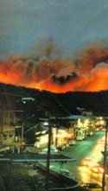

OPERATIONS MANUAL

Domestic Animals Disaster Evacuation Group

This group was formed on 10 August 2005 as a Surf Coast Shire initiative in conjunction with its members.

The members consist primarily of dog and cat boarding proprietors along with Surf Coast Shire representatives (Authorised Officers) with a concern for the welfare of pets belonging to people who have been displaced from their homes during a disaster such as fire or flood.

This operations manual has been produced for members of the Disaster Evacuation Group and interested parties. It should be used as a training manual and be taken to a Bushfire Neighbourhood Safer Place and be utilised as a reference manual.

Thank you for your interest and support of the DADEG (Domestic Animals Disaster Evacuation Group).

Brooke Ranken
Team Leader Local Laws
Surf Coast Shire
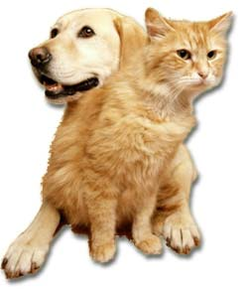
What is the Domestic Animals Disaster Evacuation Group? (DADEG)

The above group was formed by Surf Coast Shire along with boarding kennel/cattery owners within the Shire, so that domestic pet owners who evacuate their residences with their pets as a result of a disaster such as fire or flood etc, can take some positive action regarding their pets.

According to the State Emergency Service, most emergencies have shown that pets can be a huge problem when people are evacuated. The Black Saturday experience along with the Ash Wednesday bushfires in 1983, the 1993 floods in Northern Victoria, particularly Benalla, and more recently Hurricanes Katrina and Rita in the USA, demonstrated that pets at evacuation centres must be considered, and where possible, managed.

What will the Group do?

During an emergency, the Group will collect small domestic animals (dogs, cats, birds, rabbits etc) from consenting owners that have been sent to evacuation/welfare centres approved by emergency services. The animals will then be taken to the SCS pound and to local Council approved boarding establishments and be cared for short term (approximately one week, Geelong Animal Welfare may offer longer term arrangements). The owners would then collect their pets when they have reorganised their lives and found suitable accommodation.

Why is the Group needed?

Animals are not allowed inside evacuation centres and during past emergencies animals have been left in cars or unsuitable places often for days. Accordingly, the vast number of animals at evacuation centres has caused confusion for emergency personnel who have been unsure as to what to do with the animals.

In the case of large bushfires, it may be several days before residents are allowed to return to their homes.

According to the State Emergency Service, approximately 80% of people evacuated who have lost homes are able to find accommodation straight away for themselves and their pets. It is the pets of the remaining 20% of owners, who have nowhere to go, that the Group will be able to provide this service for.

What is an Emergency Response Pet Plan (ERPP)?

This plan identifies who is responsible for various tasks during emergencies and how the resources of the Shire/State can best be used to combat any emergency.

The principles behind these plans are:

- When any emergency occurs within a community, the affected people will, in the first instance, look for and accept help from local people and authorities with whom they deal every day, they know and have links with.

- When an emergency involves more than one Municipality, (we border with City of Greater Geelong, Colac Otway Shire and Golden Plains Shire), crosses a Municipal border or requires resources from other areas, plans exist for escalation to a Regional basis or a State basis, where large scale assistance and resources can be provided.

Coordination

Local Government, State, Zone and Regional Emergency Response Coordinators have been appointed to coordinate emergencies (coordinating an emergency is basically bringing together all the agencies and resources needed to combat the particular emergency and overview the whole situation).

Responsibilities

Some organisations have been given 'combat or lead agency' roles for specific emergencies or tasks related to emergencies.

Examples of combat or lead agencies include Dept Primary Industries, Red Cross, SES, Police,
CFA and Department of Human Services.

Our Group will be listed as a support organisation to the Emergency Response Pet Plan within the Surf Coast Shire and therefore will be called upon by one of the above agencies to assist with animals at an evacuation centre.

See map of the Surf Coast Shire district below.

How much will it cost?

It is anticipated that most animals would be collected by their owners within one week with minimal costs involved.

SURF COAST SHIRE DISTRICT ERPP
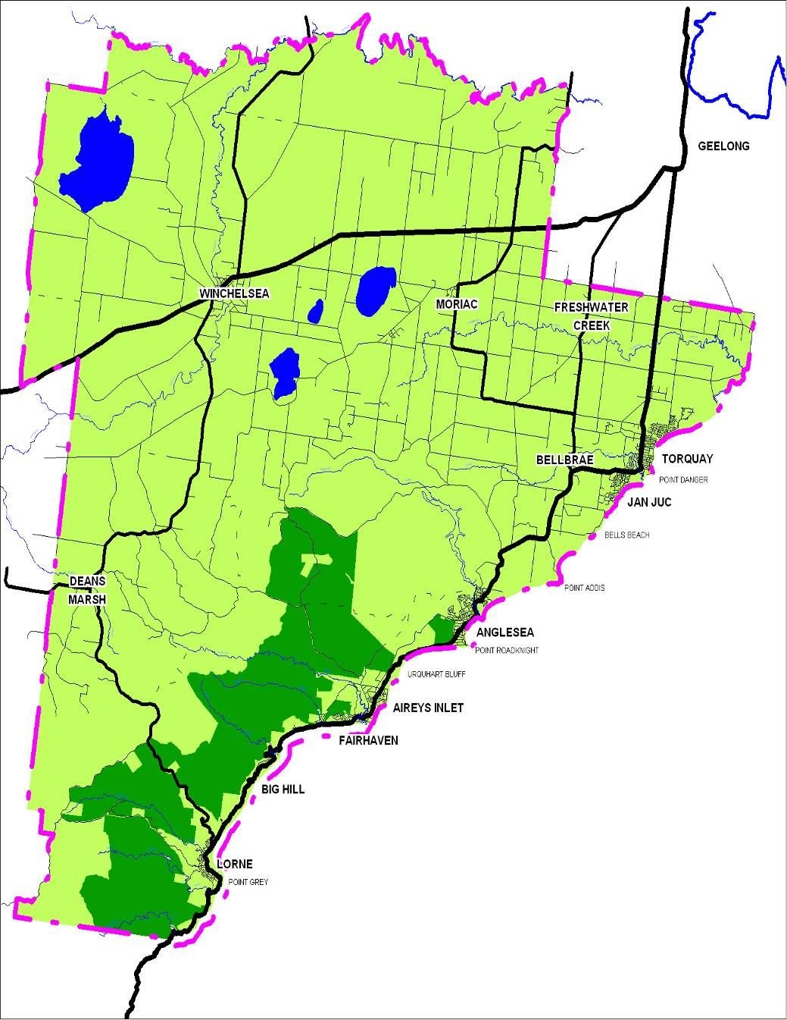

LIST OF GROUP MEMBERS WITHIN SURF COAST SHIRE

Tony Rolfs
Trevor Doueal
Robert Pitcher
John Bauer
Andrew Watson
Authorised Officers Surf Coast Shire
Approximate availability: 10+ spots

Able to collect, transport and board animals to Blackgate Road Torquay (SCS pound) and assist on a 'hands on' basis.

Members able to collect, transport and board animals:

The Dog House Pet Resort
MT DUNEED VIC 3216
Approximate availability: 20 spots (dogs only)

Woodleigh Boarding Kennels
DEANS MARSH VIC 3532
Approximate availability: 20 spots

Members able to only board animals

Approximate availability: 80 spots
Geelong Animal Welfare Society (GAWS)
325 Portarlington Road
MOOLAP VIC 3219
Telephone: 5248 2091 A/H: 5248 2626 Mobile: 0407 317 436

Vets to board/treat animals:

Torquay Animal House
TORQUAY VIC 3228
Approximate availability: 20 spots

Torquay & Surf Coast Veterinary Hospital
TORQUAY VIC 3228
Approximate availability: 15 spots

NB: All approximate availability is based on off peak times.
Group members may also contact their own network of helpers for extra assistance, animal handling and transport etc during an emergency
Should the number of animals exceed the housing capabilities of the group members, other boarding facilities that are not actively involved with the Group as well as other Veterinary Clinics (outside the area) will be asked for assistance

LIST OF BOARDING ESTABLISHMENTS OUTSIDE SCS

Boarding Establishments able to collect, transport and board animals
Tsu Lin Boarding Kennels
MANNERIM VIC 3222
Approximate availability: 22-32 spots

Peninsula Boarding Kennels
MOOLAP VIC 3221
Approximate availability: 50 spots

City Cats
MOOLAP VIC 3219
Approximate availability: 15 - 20 spots

Tallywood Boarding Cattery
DRYSDALE VIC 3222
Approximate availability: 12 spots

Annalee Boarding Cattery
NEWCOMB VIC 3219
Approximate availability: 20 spots (cats only)

Boarding Establishments able to only board animals:
Jirrahlinga All Pets Boarding Centre
BARWON HEADS VIC 3227
Approximate availability: 100 including wildlife (mobile pens also available)

Oasis Boarding Kennels
LARA VIC 3212
Approximate availability: 60 spots (no cats)

It is important to familiarise yourselves with the locations of all kennels and catteries to avoid disorientation and confusion when delivering pets after a disaster.

Vets to board/treat animals outside Surf Coast Shire

Leopold Veterinary Clinic
LEOPOLD VIC 3224
Approximate availability: 12 dogs, 10 cats

Call out procedure

- Telephone call is received from Emergency Services

- Surf Coast Shire Authorised Officers to establish the following:

Where evacuation centre is
Who is the contact person at the centre
What resources are required

- SCS Authorised Officers to call members (see flow chart) with information
received from evacuation centre(s).

- Authorised Officers to ring other boarding facilities as listed:

- With information received from Emergency Services
- To establish what space is available in those facilities
- To find out who can attend at the Bushfire Neighbourhood Safer Place for animal collection and distribution
- Or establish who has space but is unable to leave their boarding facility
- Establish what cages, leashes, transport etc is available and who will take it to the evacuation centre

- Authorised Officers collate information received and then call members with this information (who has what space and who can go etc) and this information is then passed on via the phone network IE fax, email, SMS.

- Personnel to go to evacuation centre(s) and after making contact with person in charge at centre, to collect animals from those owners needing help and distribute to boarding facilities.

- Ensure that you take with you your identification badge identifying you as a member of the Group, along with your equipment kit (contents listed on the Equipment Check List page)

- Personnel to report back to Authorised Officers when finished.

Procedure at Evacuation Centre

- Ensure you have sufficient fuel in your vehicle. Do not speed.

- Park your vehicle in the carpark or vicinity of a Bushfire Neighbourhood Safer Place (probably a community hall - but do not block the entrance to the evacuation centre.

- Ensure you have sufficient leads, cages, animal identification tags, consent forms, biros to handle the animals competently.

- Authorised Officers to explain that the Group members (who are outside the hall) have been called in by SES or Police and briefly explain the Group's role. It is possible that the person in charge of the centre may be able to make a general announcement to the public present that you are there.

- If an announcement has been made, owners may approach individual Group members. Otherwise approach owners who have pets with them and explain that you would like to assist with housing their pet if they need it. You can only assist owners who consent to releasing their pets to the Group.

It is the role of the Group to only take pets from owners who have nowhere to keep their animals for the next few days. Some owners may only be at the evacuation centre for registration purposes and have somewhere suitable to live and take their pets.

- Group members to check vehicles in the vicinity for animals locked in cars or tied to trees etc and attempt to find owners of these animals.

- Check list when a pet is presented for transportation to a boarding facility:

- Confirm the person is the owner
  - Briefly explain what the Group is doing
  - If the owner wants to release their pet to our Group, ensure the information sheet is completely filled out and the consent and release form is read and signed.
  - Place the hospital/travel tag on the animal (around neck or other place where it cannot be accidentally removed). The information on the tag will be its name, home suburb and the boarding facility to which it is going.
  - Place animal in a cage and into a vehicle or into an animal trailer for transportation. Or the owner may wish to take their pet to their appointed facility in their own car and follow you when you leave.
  - Whenever possible encourage owners to keep their pets' personal items (eg food bowls) and only take essential items necessary for the care of the pet.
  - Authorised Officers will know how many animals are being taken to which facilities, and should ensure that animals are placed in groups according to their destinations.
  - If an animal has been brought in by someone other than its owner, process the animal in the same way, but instead of filling in the consent form, use the exercise book provided for this circumstance and nominate GAWS as the animal's boarding facility.
  - There is no need to rush, remain calm and speak quietly to the owners.
  - Present and help them to fill in their consent forms if they need assistance. (Remember they could still be in shock).
  - Where possible enlist the owner's help in tagging their animal and placing it in a container or vehicle.

  - Do not insist on removing animals from owners who do not wish to relinquish them.
  - When you have collected those animals present, Authorised Officers should notify the person in charge of the evacuation centre that you are leaving and of your destination.
  - Authorised Officers to determine the likelihood of further assistance being needed from the Group.
  - Transport the animals to their various nominated boarding facilities.

Equipment Check List

The equipment to be taken to an evacuation centre will include:

- PDA to check data base and digital camera to photograph all animals.

- Spare dog leads, cat bags and cages which are owned by the individual boarding establishments. These should be clearly marked with the boarding establishment's name, either written on the item or tagged with a travel tag.

- Dog leads etc which are owned by the Group and have been distributed to the members for use in an emergency.

- A quantity of hospital type/travel tags issued to each Group member for identification tagging of animals at the evacuation centre.

- A small first aid kit to treat injuries to Group members including bites and scratches.

- A quantity of Consent/Instruction Forms which have been distributed to each Group member.

- Spare pens.

- Spare pairs of scissors to cut hospital type animal tags.

- Photograph and record animals which have been brought into an evacuation centre without owners.

- Badges/laminated identification badges.

Domestic Animals Disaster Evacuation Group (DADEG)

What is the DADEG?
We are a group made up of SCS representatives and cat/dog boarding facility owners who want to offer emergency short term accommodation for your loved pet at a time when a disaster such as today has happened.

What does the Group do?
We will take your pet to a Council approved boarding facility for a short time until you are able to reorganise your life and be able to collect your pet. Your pet will be loved and well cared for in your absence at the boarding facility.

CONSENT FORM

If you would like to use our service please complete the information below:

Your Details: (Please Print)

Name: ……………..………………………………….…..………………..………………………
Address: ……………………… …………………………..……………………………..…………..
……………………………………………………………………..………………………..
Phone No: ……………Mobile: …………...……..………………Email:………..…………
Temporary Address: …………………..……...………………………..……………………………….
…………………………..………….……………………...……………...………………..
Name of Employer: ………………..………...…………………………..……………………………..
Employer Phone No: ……………..…………..……………………..……………….…………………

Pet Details
Type of Pet: ……………Breed:…………………………………… Microchip: Yes □ No □
Colour(s): ……………………………………......... Sex: Male □ Female □
Council Tag No:……………………Pet's Name: ……..……………………… Age: ………………..
What medication is your pet taking? …………………………………………………..………………
Do you have this medication with you: Yes □ No □
What vaccinations has your pet received in the last 12 months? ….……………………………….
Are there any special instructions we must know to help us to care for your pet?
………………………………………………………………………………..……………………………
The Nominated Boarding Facility Details:
Your pet will be taken to:
Facility Name:……………………………………..……………………………………………………..
Facility Address: …………………………..…………………………………………………………….
Contact Person: ………………………………………Phone No: …………..………………….

Please contact the Boarding Facility within 48 hours to arrange collection or to give a report on when you can collect your pet.

Please read and sign the Agreement & Release Form (below)
I, the above named give DADEG permission to transport my animal(s) to the nominated boarding facility (named above) and indemnify the Group/Surf Coast Shire of any costs and/injuries that may occur in this process and whilst being cared for by the nominated Boarding Facility.

Name: …………………………………………………………………………………..
Signature: ………………………………………………………….………..………………………..
Date: …………………………………………………………………………………..

Appendix C

– Dog Regulation Maps

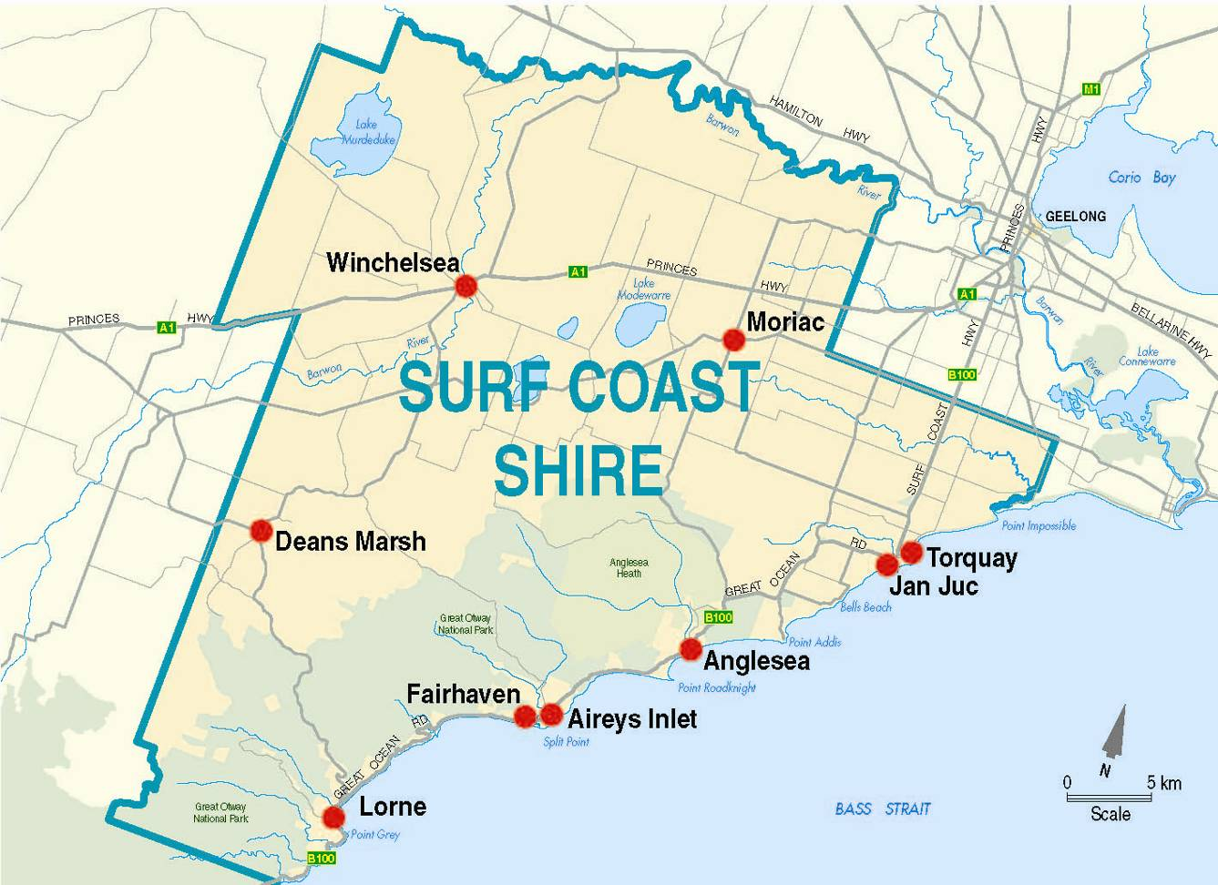

Aireys Inlet

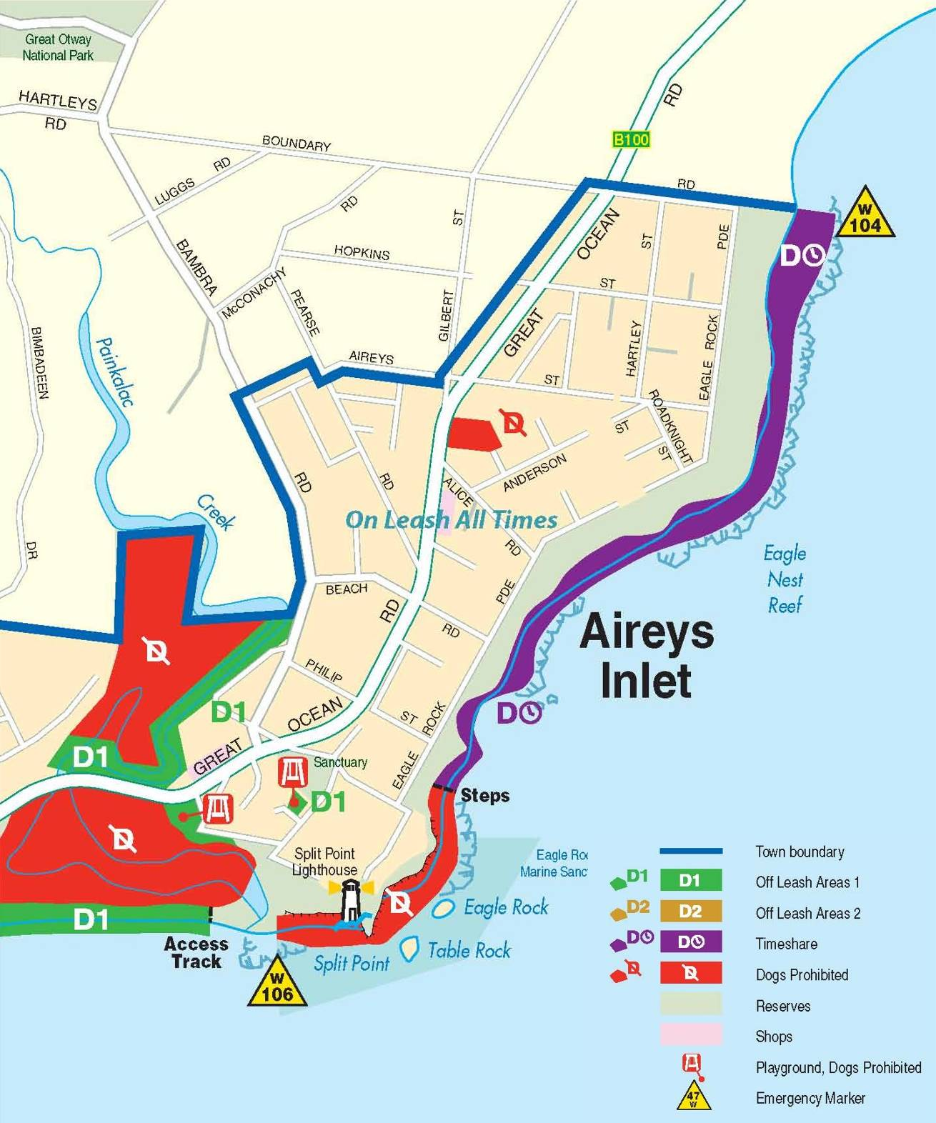

Anglesea

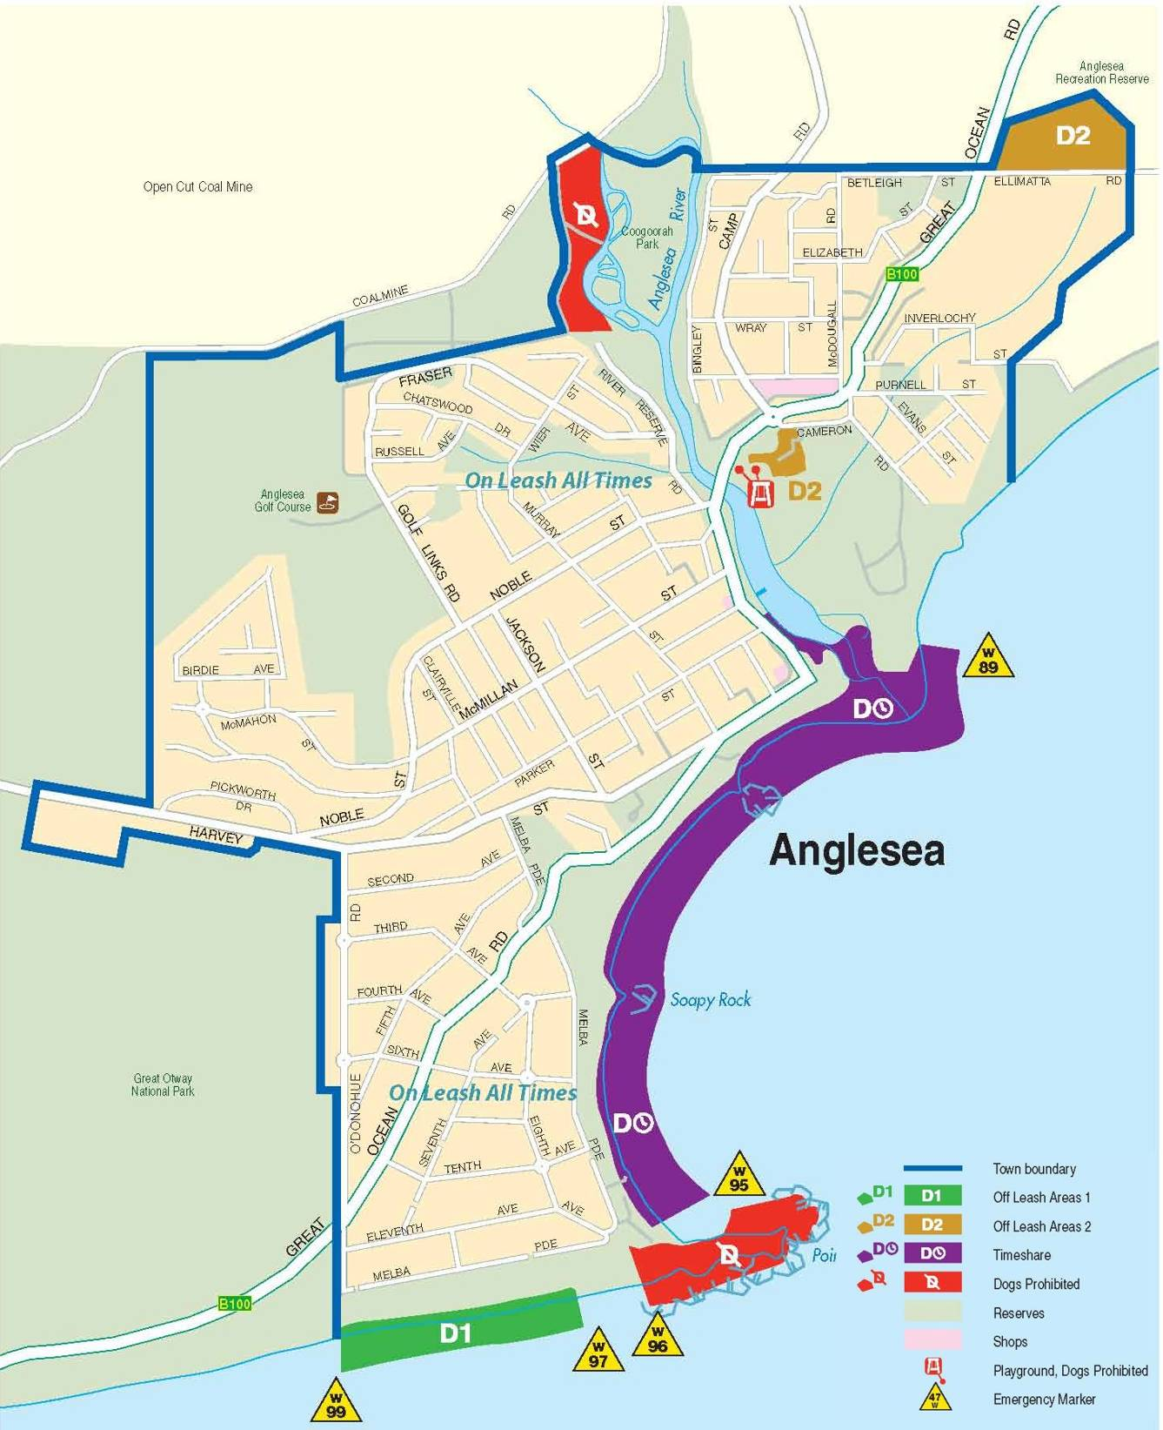

Deans Marsh

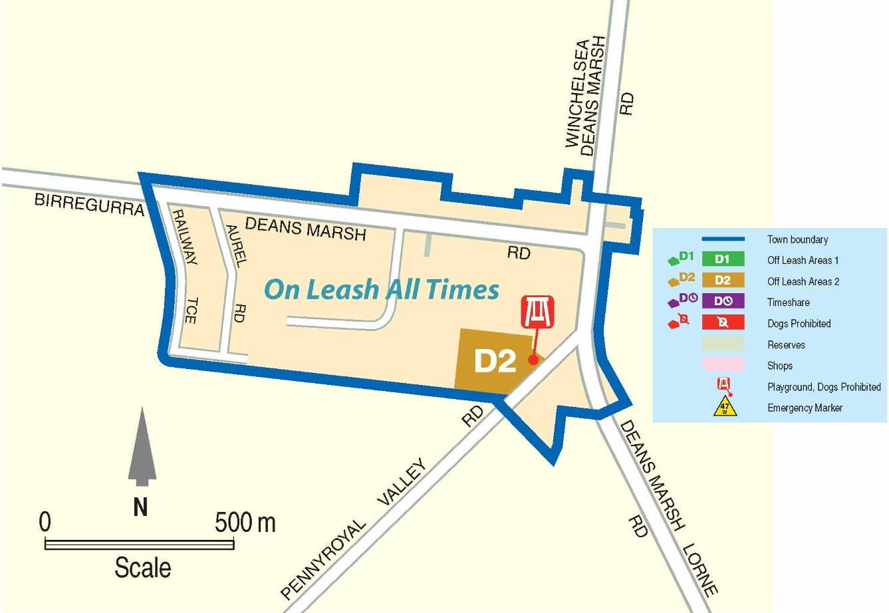

Fairhaven / Moggs Creek

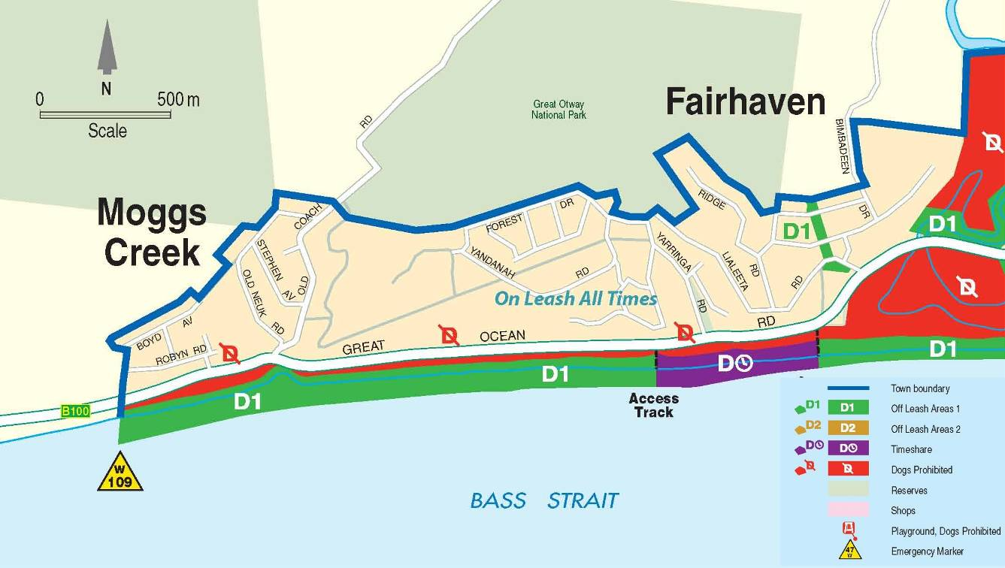

Jan Juc

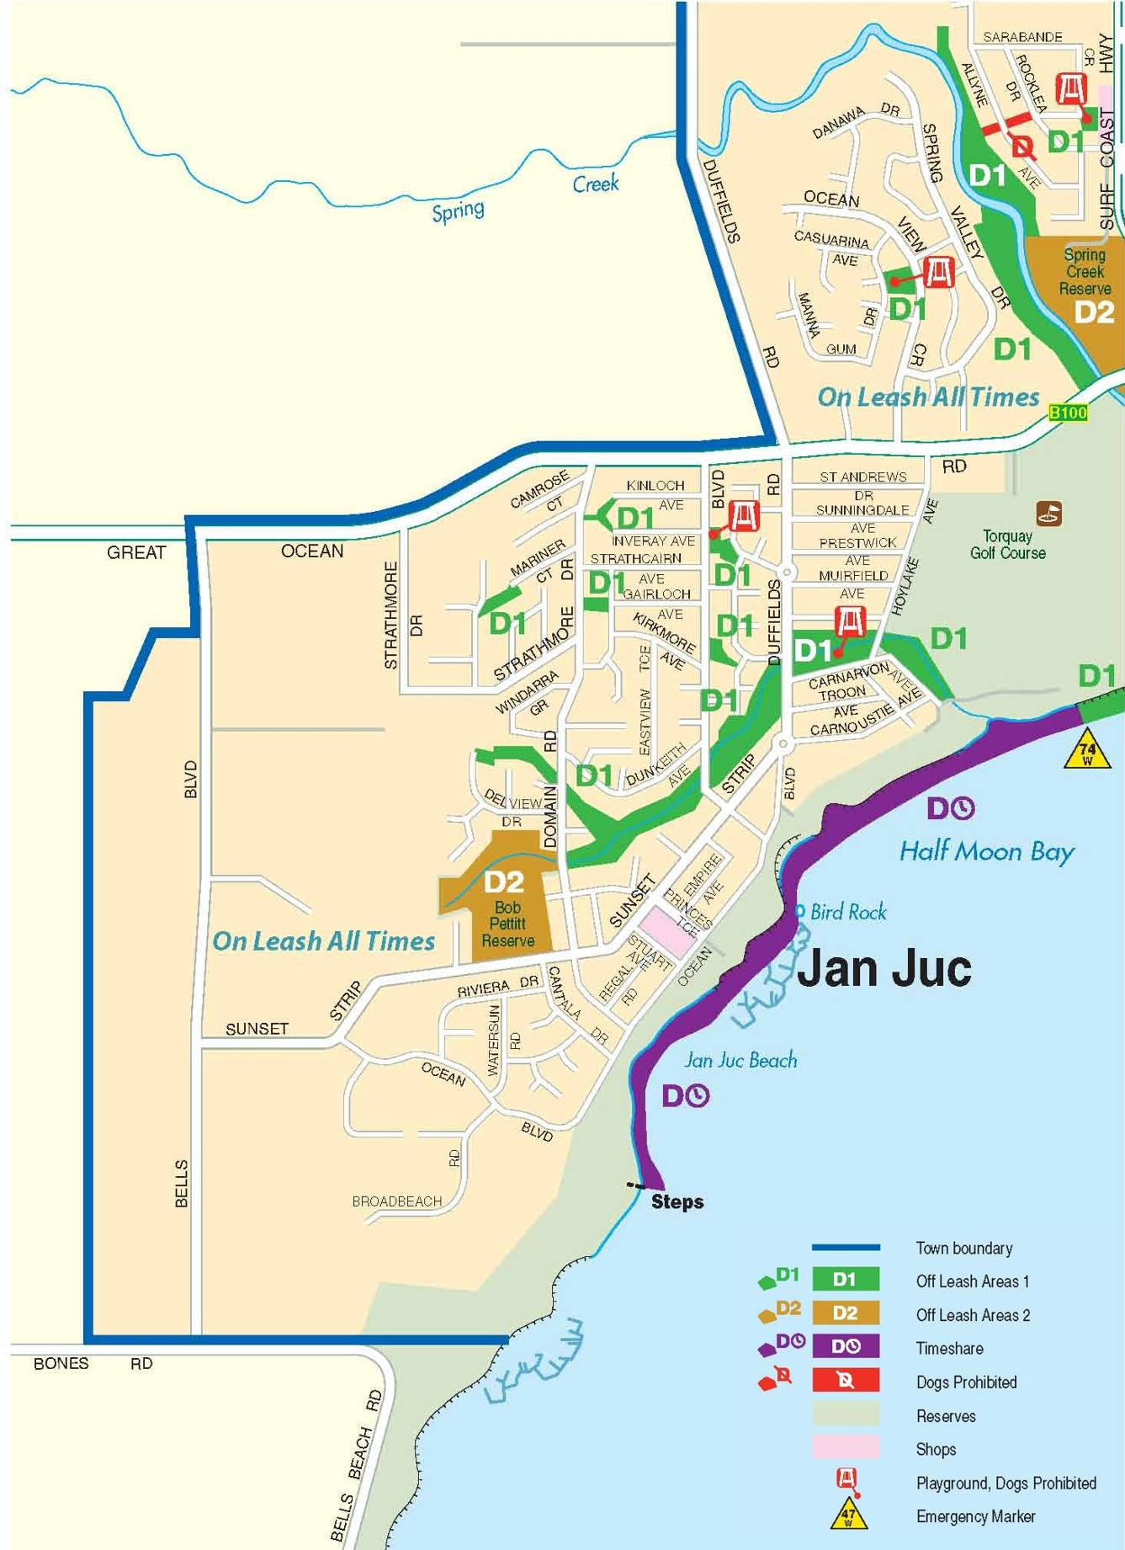

Lorne

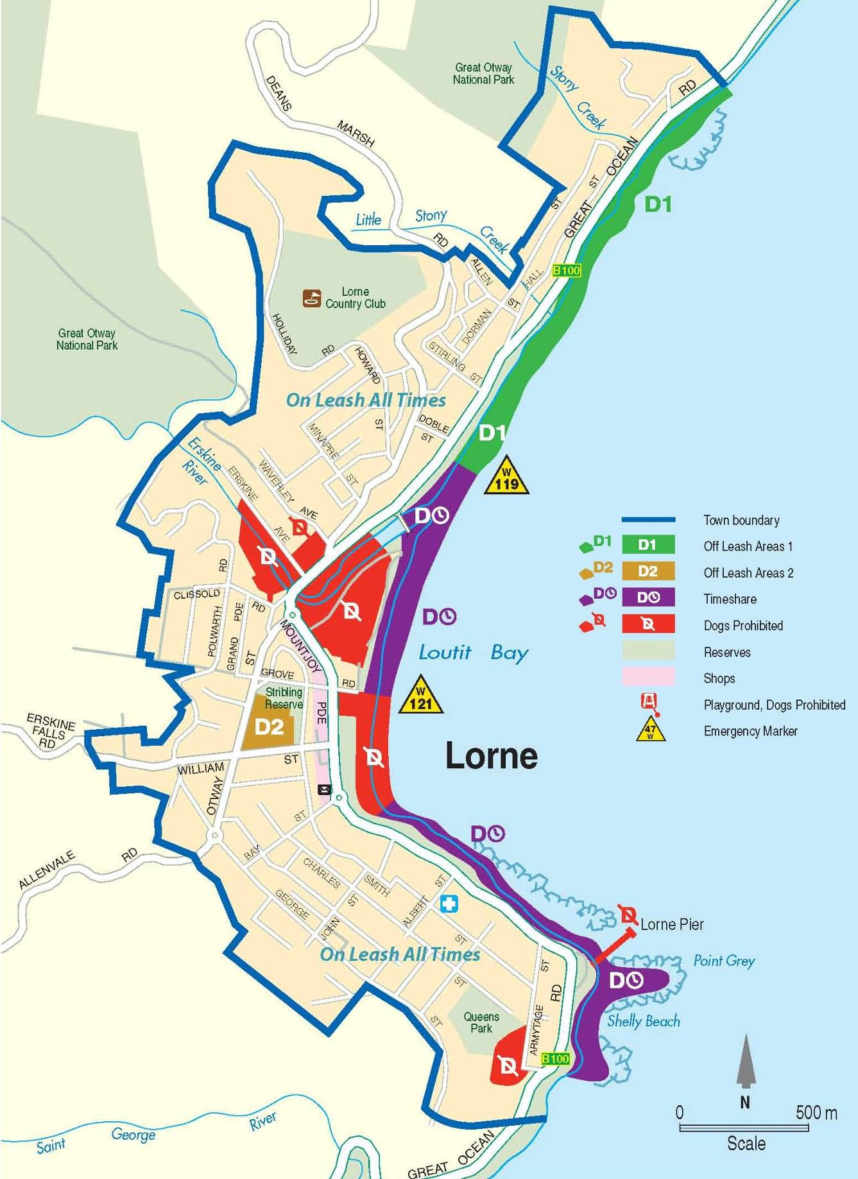

Moriac

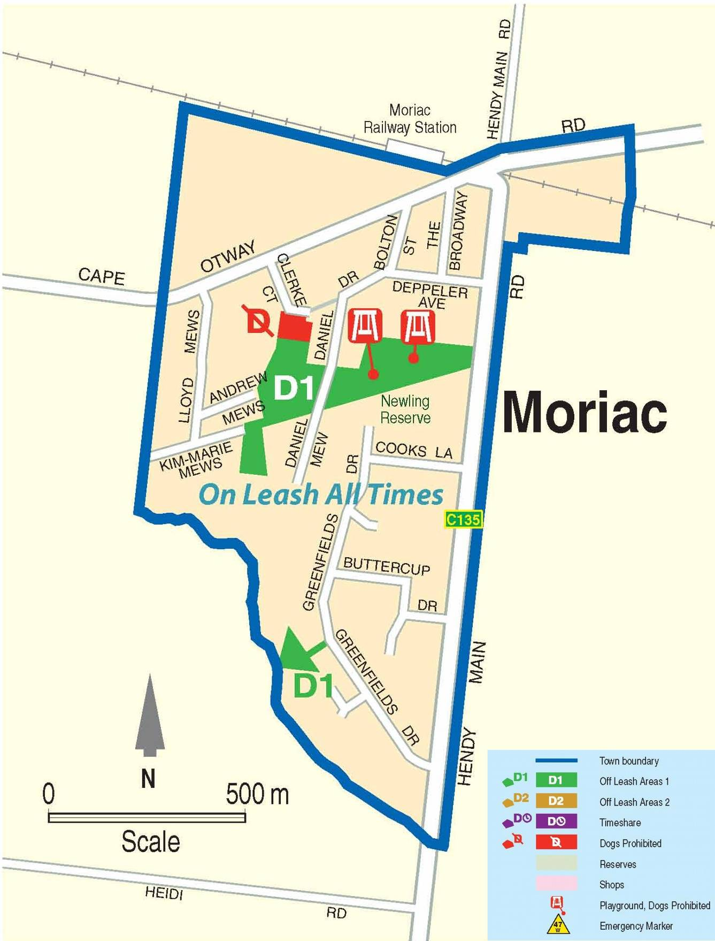

Torquay

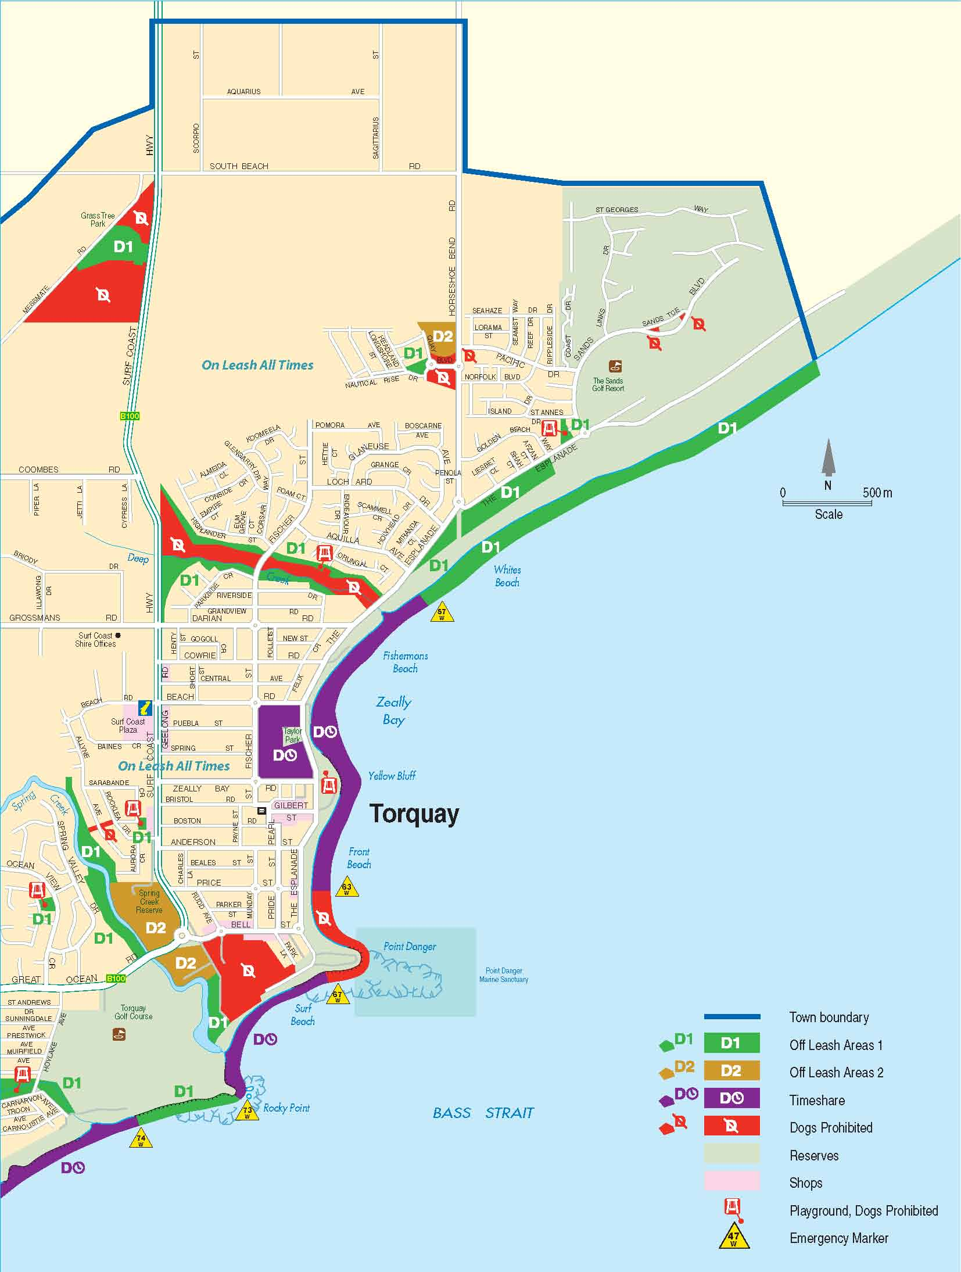

Winchelsea

