
Access and Inclusion Action Plan 2021-25:

Summary: Final Progress Report 2024-25
This summary provides a brief overview to our Final Progress Report 2024-25 on Council’s Access and Inclusion Action Plan 2021-25. The Action Plan has five goals to help Council build healthy, well-connected communities where everyone can participate:
- Built and natural environments
- Services and information
- Social and civic participation
- Addressing discrimination and supporting inclusion
- Council Workforce Inclusion and Diversity
For the full report, please see Council's Disability Inclusion website, or contact the Disability Inclusion Advisor by lodging an online request or calling 5261 0600.

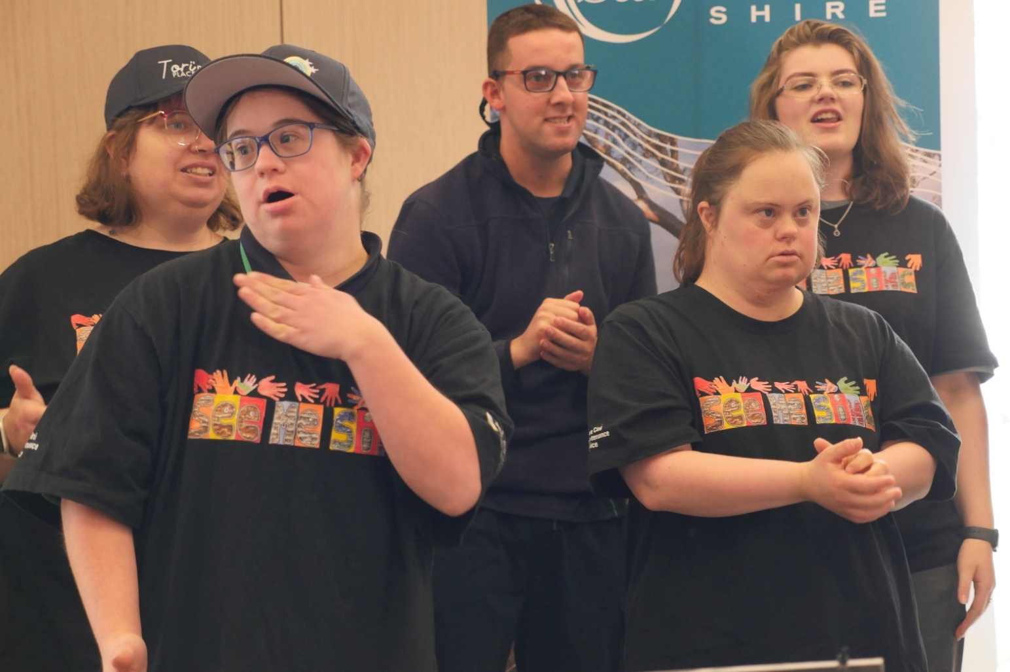
Image: All Aboard disAbility Support Services See Me Sing Choir performing at Council’s Local Legends Awards
STRATEGIC OBJECTIVE 1: Built and natural environments

Goal: Built and natural environments are well designed and accessible for people of all abilities, and planned to adapt to our community’s future accessibility needs

Highlights 2024-2025
- Accessible upgrades to six community facilities completed including: Eastern Reserve (Winchelsea), Torquay Kindergarten, Anglesea Historical Society, Anglesea Community House, Anderson Roadknight Reserve (Aireys Inlet) and Wurdi Baierr Stadium (Torquay).
- Staff training in Universal Design and the Disability Discrimination Act was attended by 10 teams across the organisation.
- Online accessibility tools implemented by key Council facilities so community members can ‘know before they go’: Australian National Surfing Museum, Torquay Civic Office, and Wurdi Baierr Stadium.
- Eight portable hearing loop kits were purchased and made available for free hire by local community groups.

Actions in progress
- Improving project management and procurement processes to improve access and inclusion outcomes.
- Implementing the Accessible Carpark Audit 2022 to ensure Council’s accessible carparks to current DDA standards.

STRATEGIC OBJECTIVE 2: Services and information

Goal: Accessible, flexible, people-centric services and information, responsive to

Highlights 2024-2025
- Online resources and support for local businesses to support them to be more inclusive.
- Disability awareness training for Emergency Relief Centre volunteers, and inclusion-focused Emergency Relief Centre training day for staff volunteers and local emergency services.
- Improved inclusion at the Australian National Surfing Museum including sensory kits for museum visitors, and accessibility criteria for design work in exhibition redevelopment.
- Launch of the Hidden Disability Sunflower scheme at all Council Maternal and Child Health Services across the Shire

Actions in progress
- Updating Council’s access maps which were created in 2017 for major townships across the Shire.

STRATEGIC OBJECTIVE 3: Social and civic participation

Goal: People of all abilities actively participate, socialise and have fun in the community and contribute to local decision making

Highlights 2024-2025
- Ongoing support for the function of Council’s Disability Advisory Committee who provide advice to Council on a range of projects and policies. Strengthened focus on lived experience representation in the committee.
- Updating Council grant stream assessment processes to improve access and inclusion outcomes.
- Increased recognition for inclusive community volunteering by making improvements to our Local Legends program.
- Supporting community members with disability to volunteer in our community by working in partnership with local disability employment services.
- Making Council and community events more inclusive for people with disability by providing inclusive events guidelines and resources for event organisers.

Actions in progress
- Supporting employment of local people with disability by providing guidance and support to local businesses.

STRATEGIC OBJECTIVE 4: Addressing discrimination and supporting inclusion

Goal: Council actively promotes the importance of inclusion for all, addressing discriminatory attitudes and supporting inclusive practices

Highlights 2024-25
- Annual celebration of International Day of People with Disability including: disability-themed story time at Torquay Library, exhibition at Anglesea Art Space and various media campaigns.
- Disability awareness training session provided by Scope to local community groups and volunteers.
- Launch of the accessible café and restaurant map, which provides information on accessibility entry, bathrooms, parking, and ability to make adjustments at local businesses.

STRATEGIC OBJECTIVE 5: Council Workforce Inclusion and Diversity

Goal: A workforce that embraces diversity and is responsive to the needs and aspirations of people with a disability

Highlights 2024-25
- Council’s first Workplace Adjustment Policy rolled out including staff training sessions from Job Access for all managers and coordinators.
- Access and Inclusion Hub created on the staff intranet providing resources and guidance for employees and supervisors around employment for people with a disability and carers.
- Making recruitment processes for staff more inclusive by embedding workplace adjustments throughout the process.
- Improved inclusive volunteering by providing disability awareness and workplace adjustment training to volunteer leaders, and increasing inclusive recruitment practices.

Actions in progress
- Mandatory online disability awareness training for all staff is being planned.

Next steps
A new action plan is being developed for 2026-2031, and will include community engagement with our local Surf Coast Shire community.
Learn more: via our website Council website - Disability Inclusion - Strategic Planning, or contact Council’s Disability Inclusion Advisor on 5261 0600 or by lodging a request online.

